Kapture - MDM (Master Data Maintenance) SST Management Unit Test Cases

Contents
1. User System Access 3
2. SST - Maintenance 3
2.1 Abbreviation 4
2.2 Division 18
2.3 Section 23
2.4 SST 29
2.5 Model 39
3. SST - Vehicle Type Management 41

Kapture - MDM (Master Data Maintenance) - SST Management
Unit Test Cases
Application URL: https://na.dev.mgss.oc.mazda.com/mdmgt
Application: mdmgt.war (/mdmgt) | Version: v2 | Date: 16-Oct-2026
- Unit Test Case Summary:
# | Test Cases Processes | No. of Test Cases | No. of Success | No. of Failure | Status
1 | User System Access | 1 | 1 | 0 | Pass
2 | SST - Maintenance | 20 | 20 | 0 | Pass
3 | SST - Vehicle Type Management | 6 | 6 | 0 | Pass
 | Total | 27 | 27 | 0 | Pass

User System Access
- User should be able to open MDM and view the SST Management tab on My Page.
Steps:
1. Log in to MGSS with a valid user.
2. Open the URL: https://na.dev.mgss.oc.mazda.com/mdmgt
3. Click the SST Management tab.
Expected Result: The tab lists the tiles SST - Maintenance and SST - Vehicle Type Management.
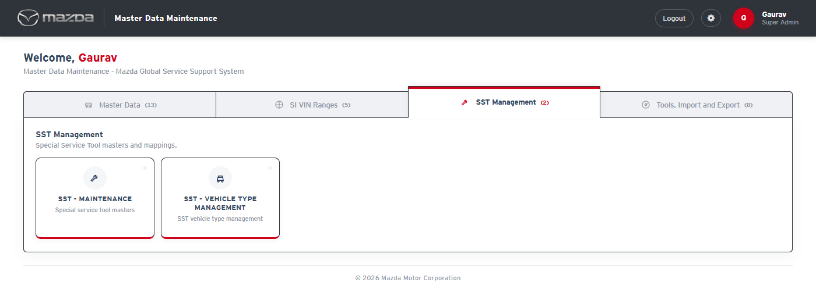
My Page - SST Management tab
Status: Pass
Remarks:

SST - Maintenance
SST - Maintenance holds the Special Service Tool masters. The screens in the top menu are maintained in sequence: Abbreviation, Division, Section, SST Image, USE Image, SST, Parent SST Mapping, Model, Adaptive Model, Tool Numbers Comparison Chart, SST MDM VIN Mapping and Upload Images; a later screen uses the data of the earlier ones. The cases below are executed with Country Code United Kingdom and Language English on the major screens in the same order. The other screens offer the same functions (Save, Edit, Active / Inactive, Export, Download Template and Import with the ACTION column) and have been tested.

2.1 Abbreviation
- User should be able to open the SST - Maintenance screens and the Abbreviation screen.
Steps:
1. From My Page > SST Management, click SST - Maintenance.
2. Select Country Code United Kingdom and Language English.
Expected Result:
- The Abbreviation screen opens with the SST - Maintenance menu (Abbreviation to Upload Images) at the top.
- Master Details lists the abbreviations of the market with code, name, status and times.
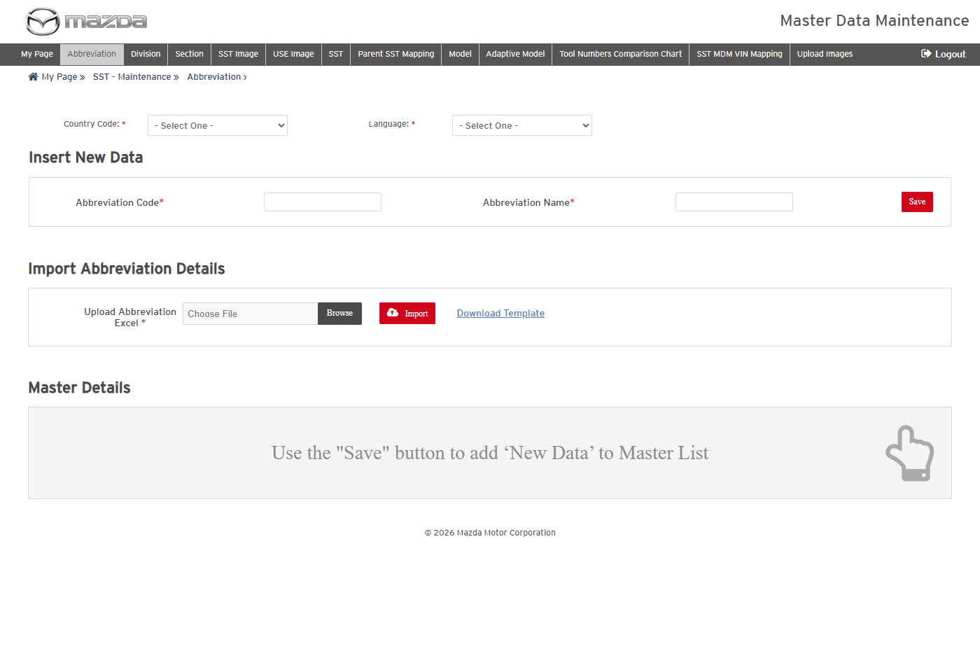
SST - Maintenance - Abbreviation
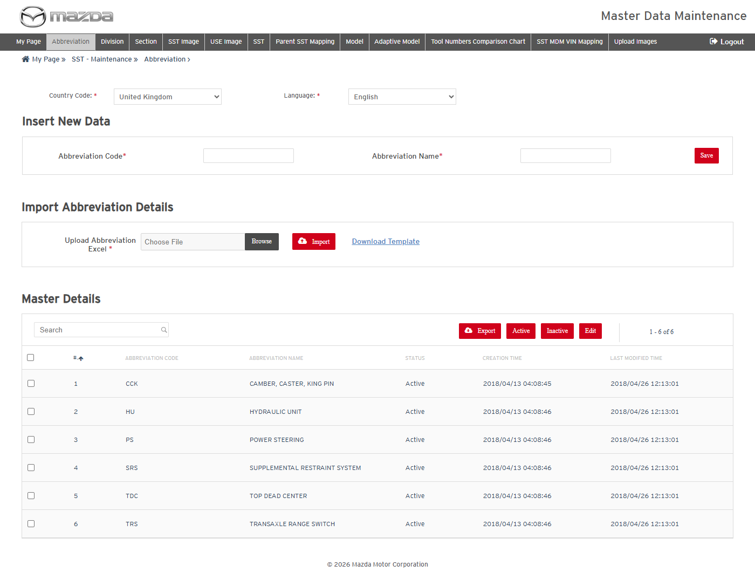
Abbreviations - United Kingdom / English
Status: Pass
Remarks:

- System should not save an Abbreviation without the mandatory fields.
Steps:
1. Select Country Code United Kingdom only.
2. Click Save.
Expected Result: "Please fill all the fields marked as mandatory (*)." is shown.
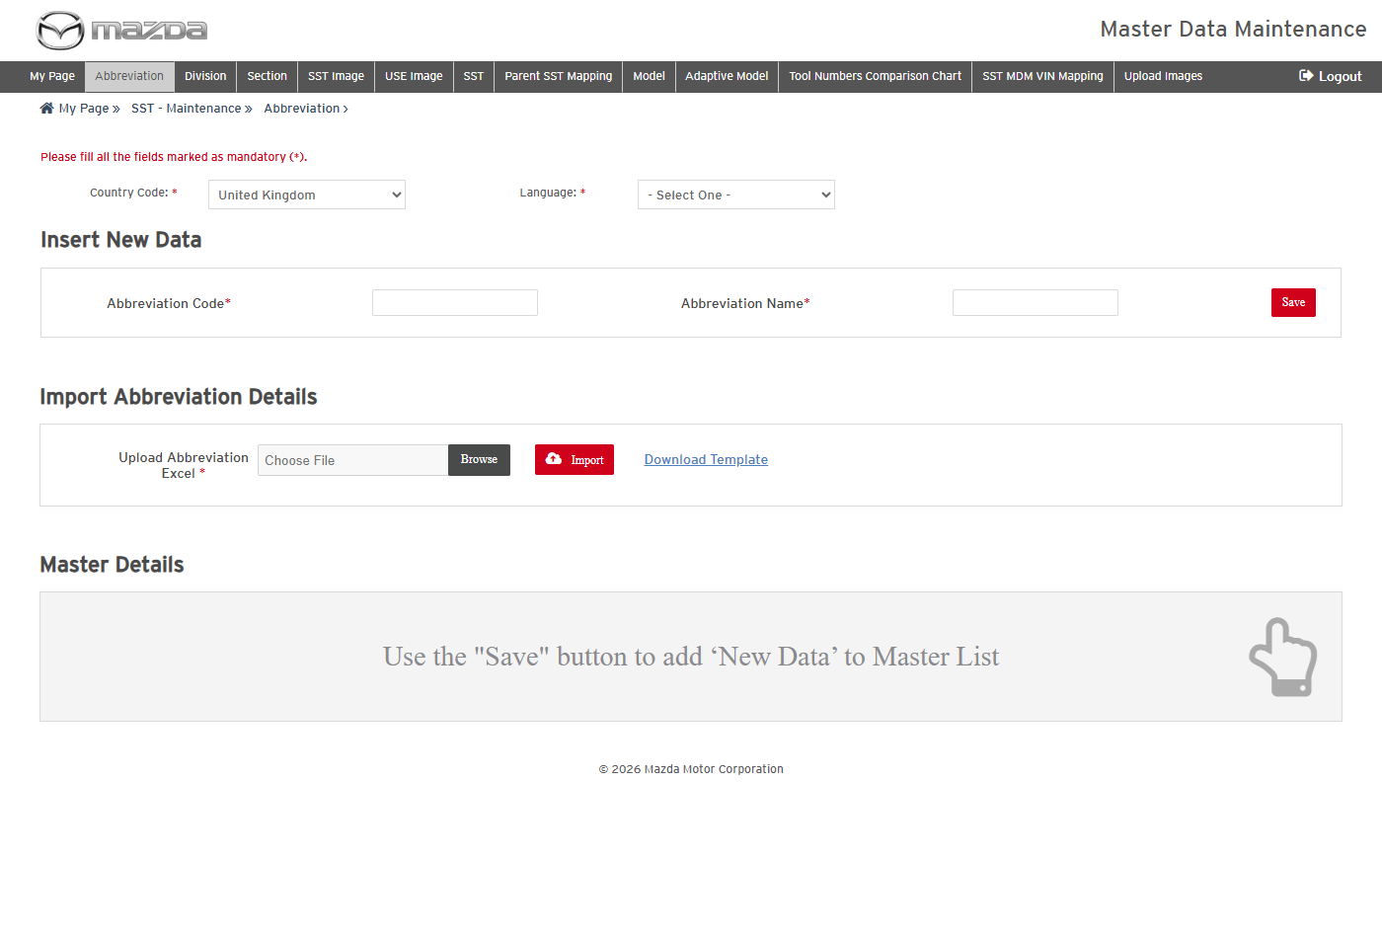
Mandatory field message
Status: Pass
Remarks:

- User should be able to add a new Abbreviation.
Steps:
1. Select Country Code United Kingdom and Language English.
2. Enter Abbreviation Code UTC and Name UNIT TEST CODE.
3. Click Save.
Expected Result: "Abbreviation details saved successfully." is shown and UTC is listed with status Draft.
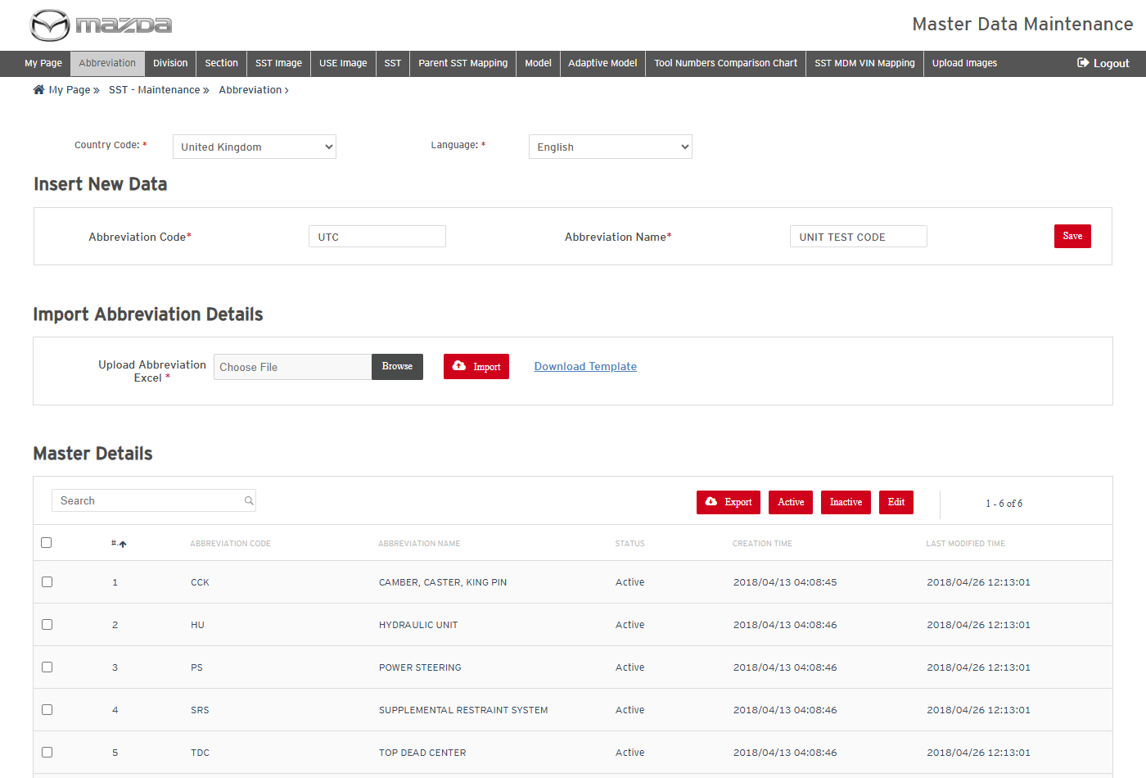
New Abbreviation
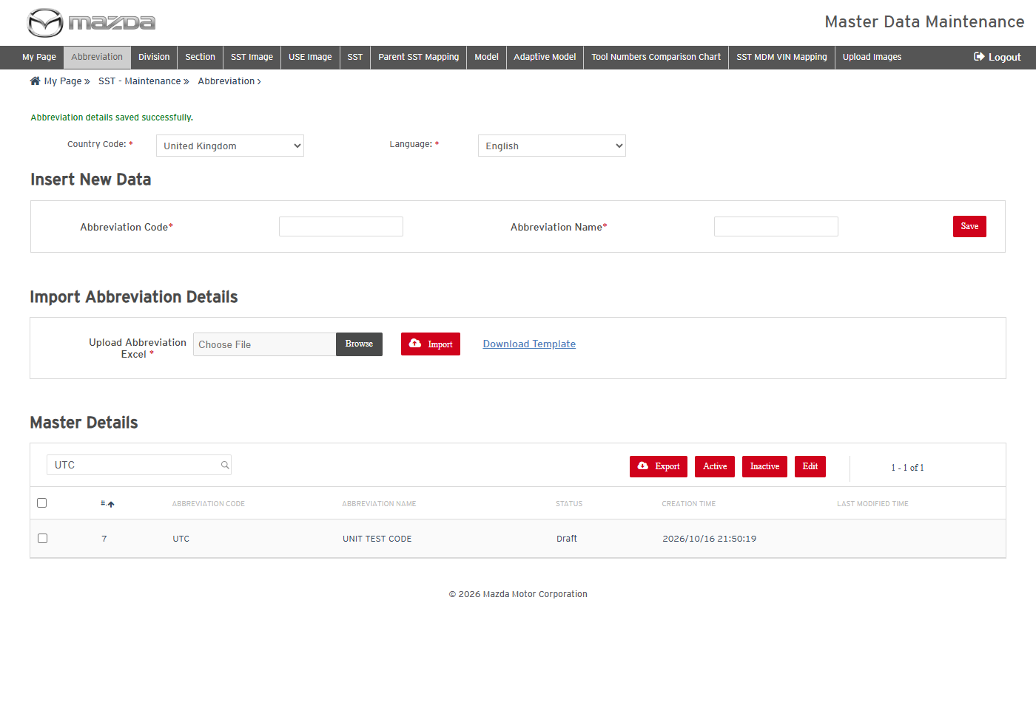
Abbreviation saved
Status: Pass
Remarks:

- User should be able to edit an Abbreviation.
Steps:
1. Select the UTC row and click Edit.
2. Change the name to UNIT TEST CODE UPDATED.
3. Click Save.
Expected Result: "Abbreviation details updated successfully for Row No. (7)." is shown with the new name.
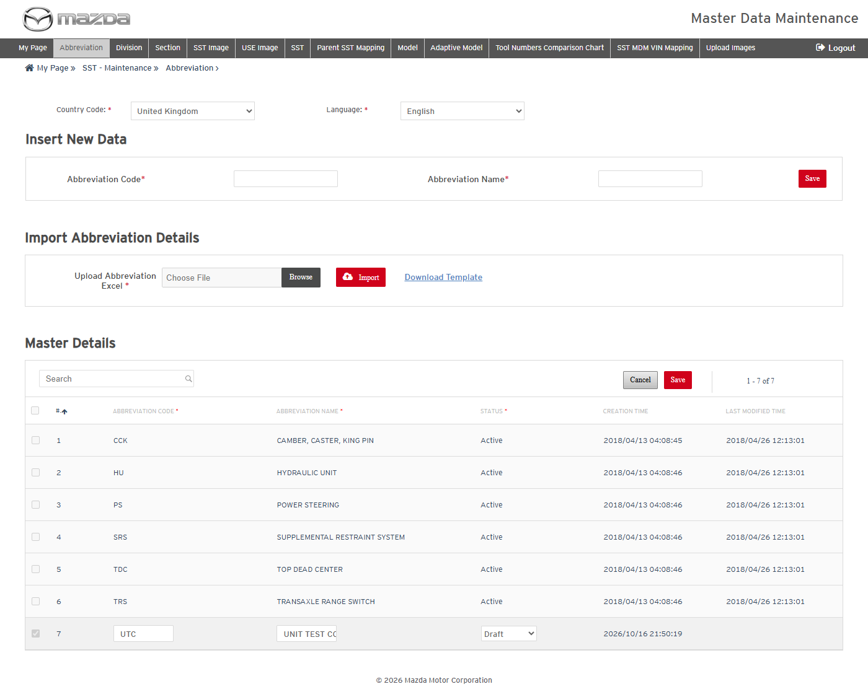
Edit mode
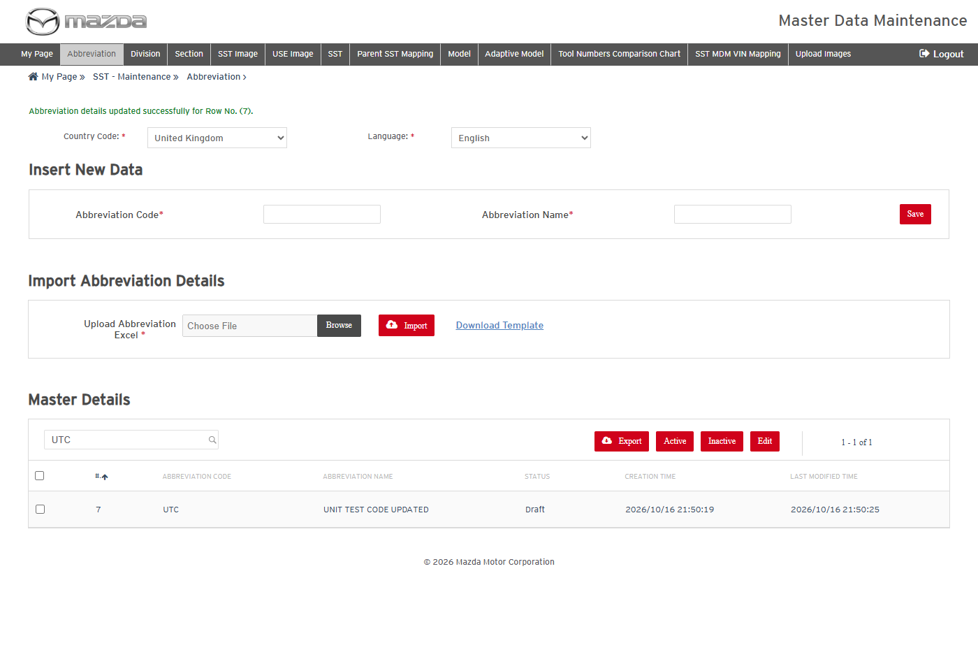
Abbreviation updated
Status: Pass
Remarks:

- User should be able to activate a Draft Abbreviation.
Steps:
1. Select the UTC row and click Active.
2. Click Yes on the confirmation.
Expected Result: "Abbreviation changed to Active successfully." is shown and the status is Active.
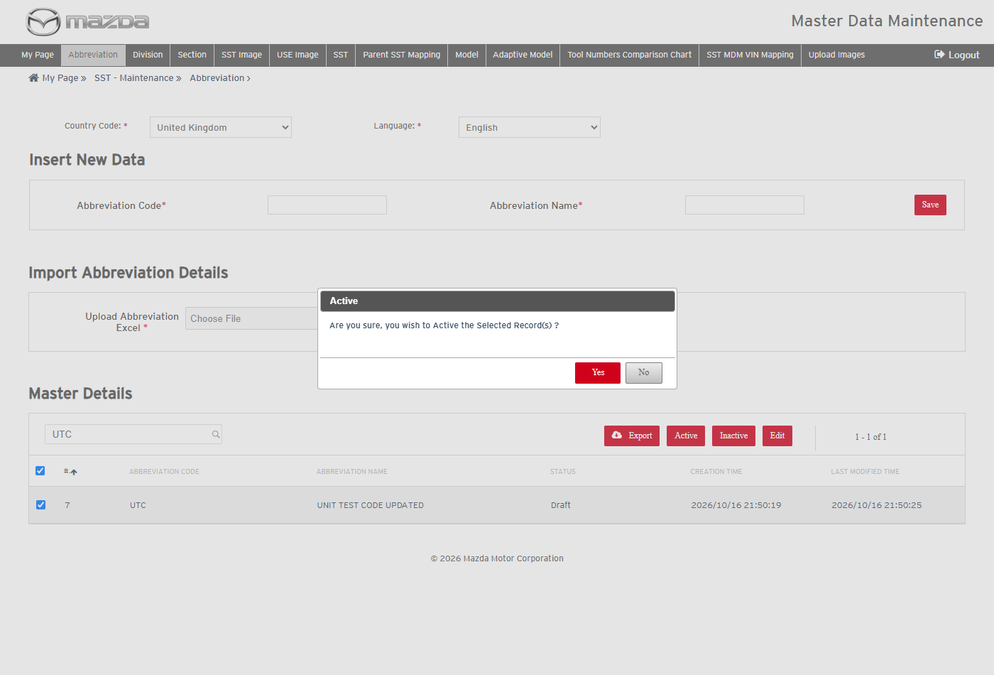
Active confirmation
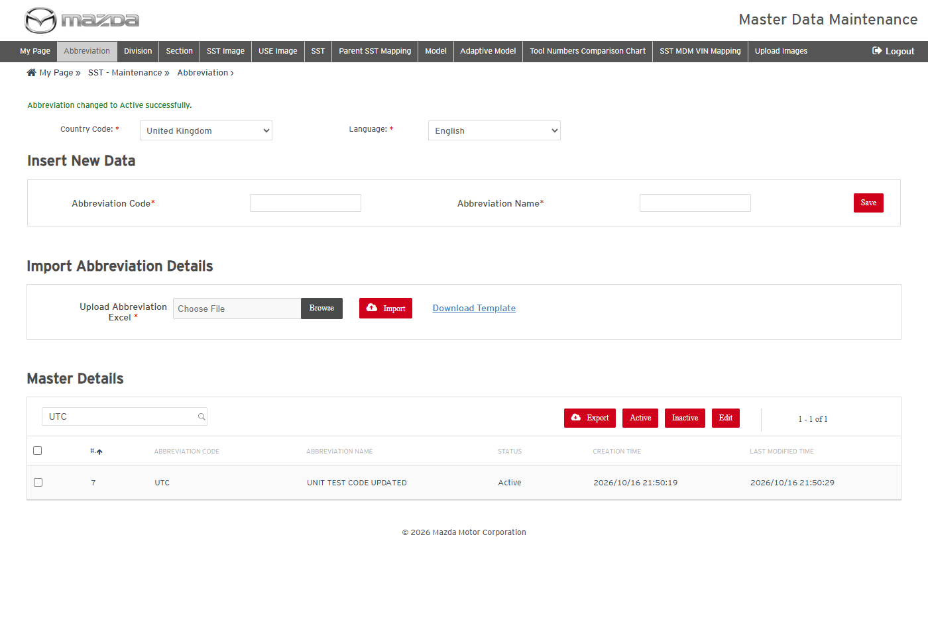
Abbreviation active
Status: Pass
Remarks:

- User should be able to export the selected Abbreviations.
Steps:
1. Select the UTC row and click Export.
2. Open the exported Excel.
Expected Result: The Excel lists the selected abbreviation code and name.
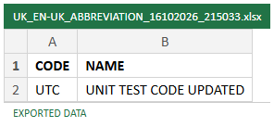
Exported Excel
Status: Pass
Remarks:

- User should be able to add and update Abbreviations by import (Action A / U).
Steps:
1. Click Download Template.
2. Fill UTC2 / UNIT TEST CODE 2 with Action A and UTC / UNIT TEST CODE IMPORT with Action U.
3. Choose the Excel in Upload Abbreviation Excel and click Import.
Expected Result: "2 rows successfully imported." is shown; UTC2 is added and the name of UTC is updated.
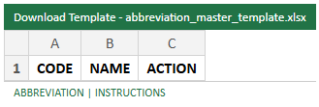
Import template
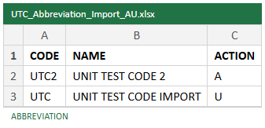
Import file - Action A / U
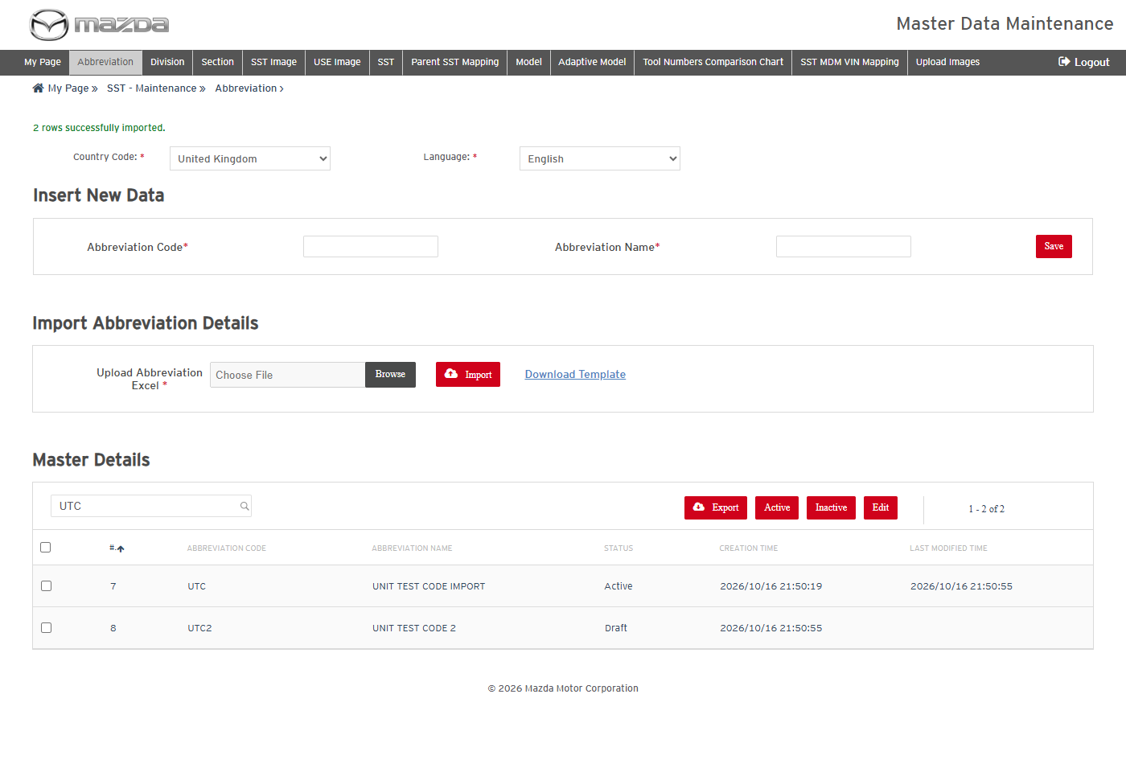
Import result
Status: Pass
Remarks:

- User should be able to delete Abbreviations by import (Action D).
Steps:
1. Fill UTC2 with Action D in the template.
2. Choose the Excel and click Import.
Expected Result: "1 rows successfully deleted." is shown and UTC2 is no longer listed.
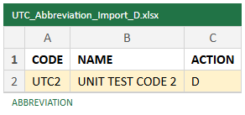
Import file - Action D
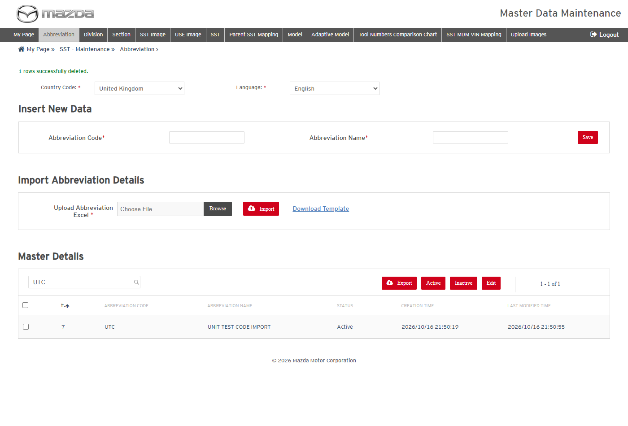
Import result - deleted
Status: Pass
Remarks:

- User should be able to inactivate an Abbreviation.
Steps:
1. Select the UTC row and click Inactive.
2. Click Yes on the confirmation.
Expected Result: "Abbreviation changed to Inactive successfully." is shown and UTC is no longer listed.
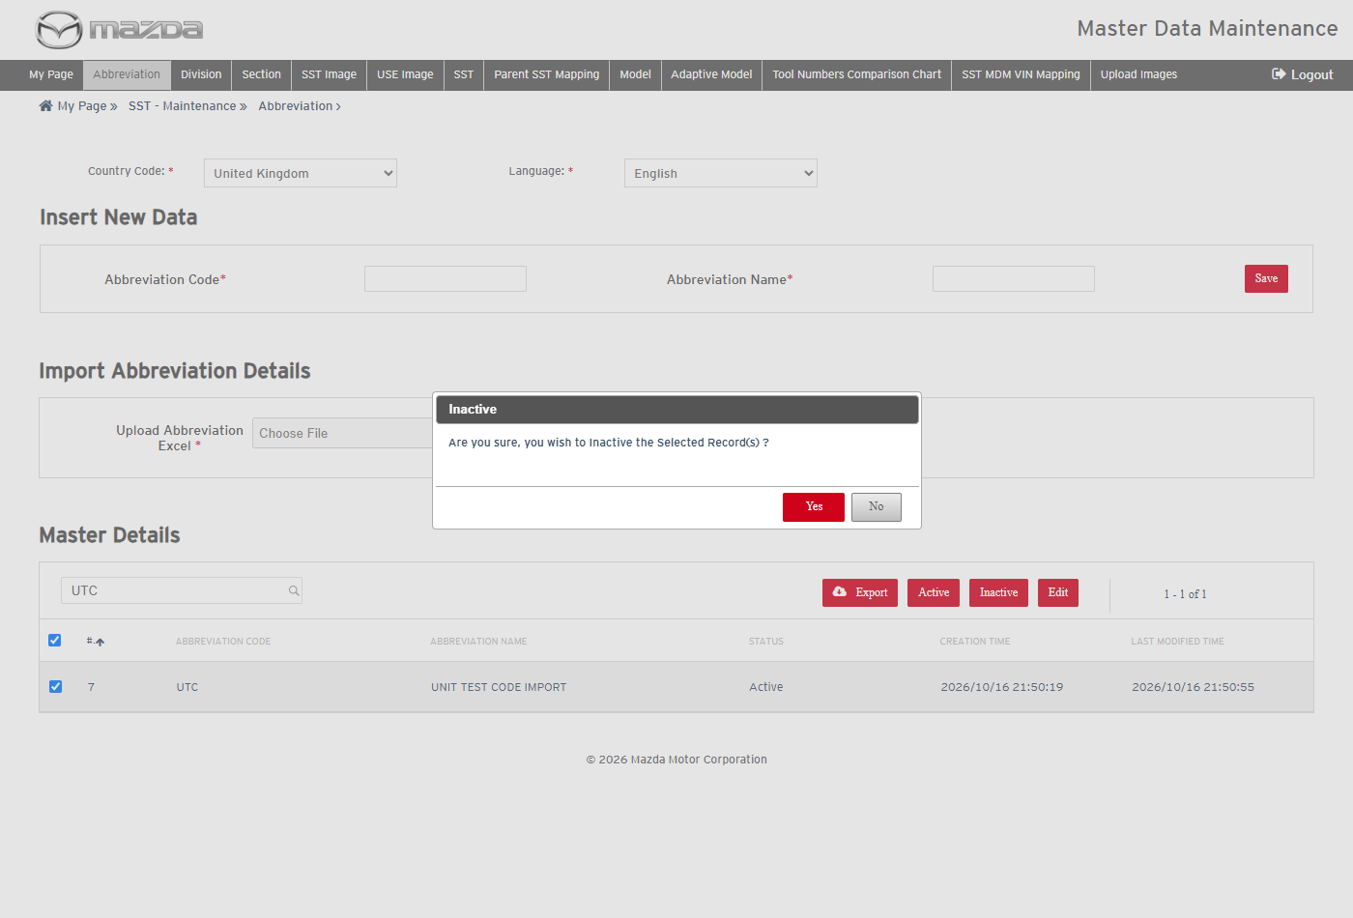
Inactive confirmation
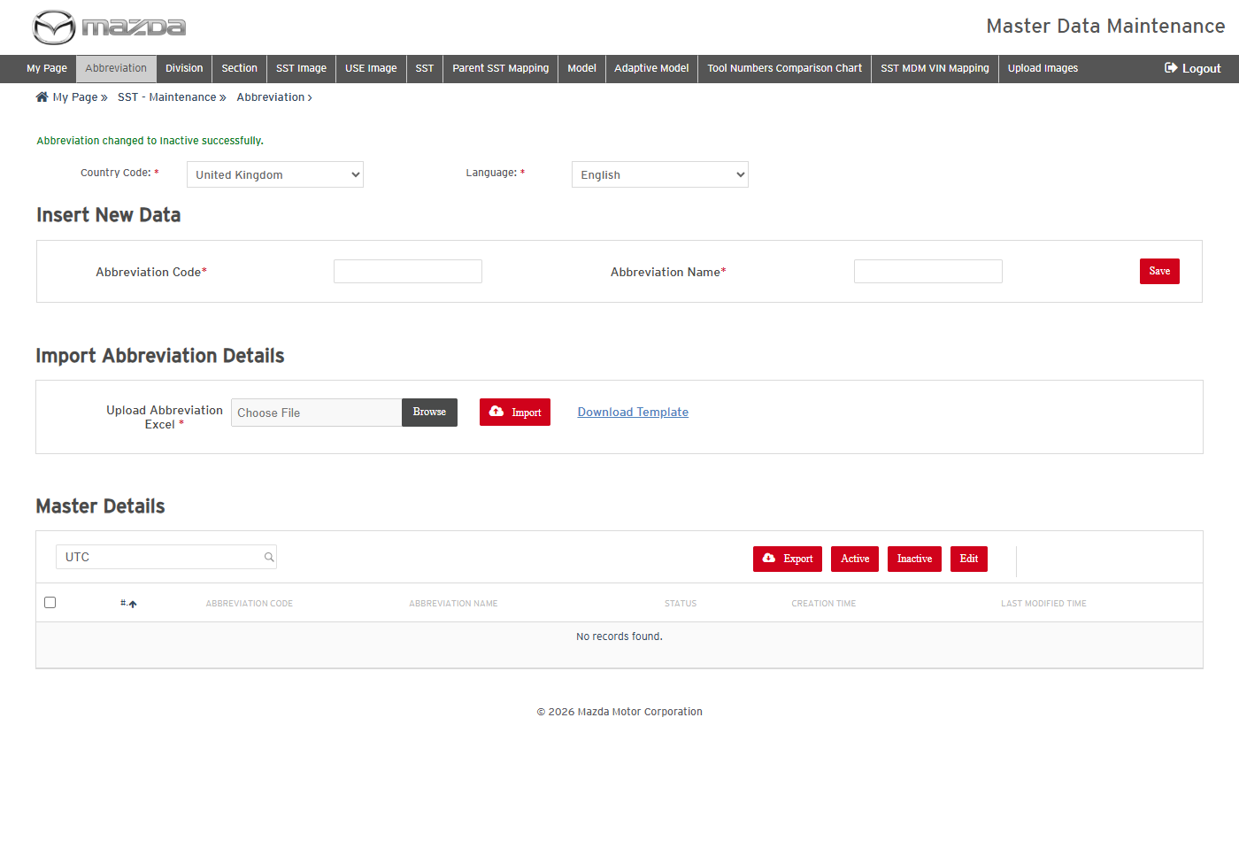
Abbreviation inactivated
Status: Pass
Remarks:

2.2 Division
- User should be able to add and activate a Division.
Steps:
1. Click Division in the top menu and select Country Code United Kingdom and Language English.
2. Enter Division Code UTC, Name UTC DIVISION and Sort Id 99; click Save.
3. Select the UTC row, click Active and click Yes.
Expected Result:
- "Division details saved successfully." is shown and UTC is listed as Draft.
- "Division changed to Active successfully." is shown and the division is available on the next screens.
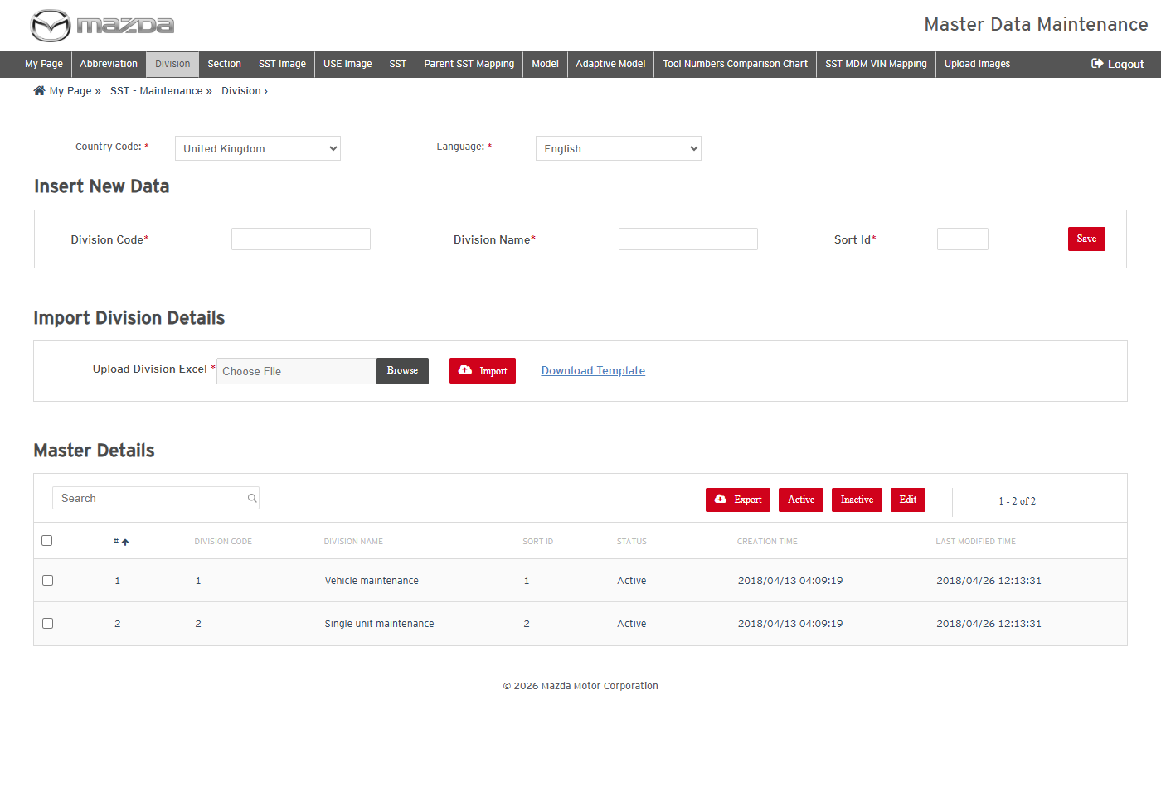
Divisions
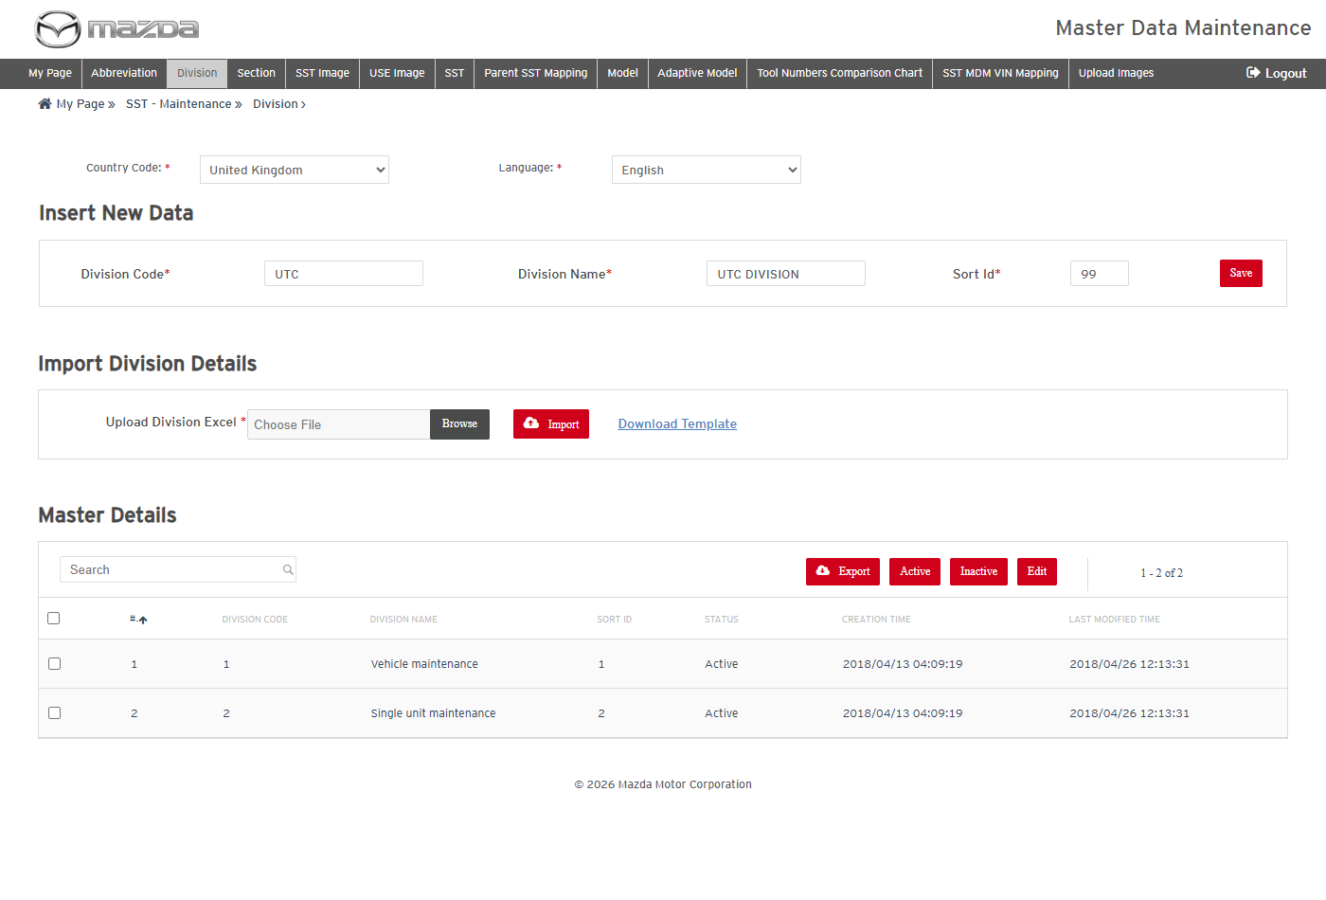
New Division
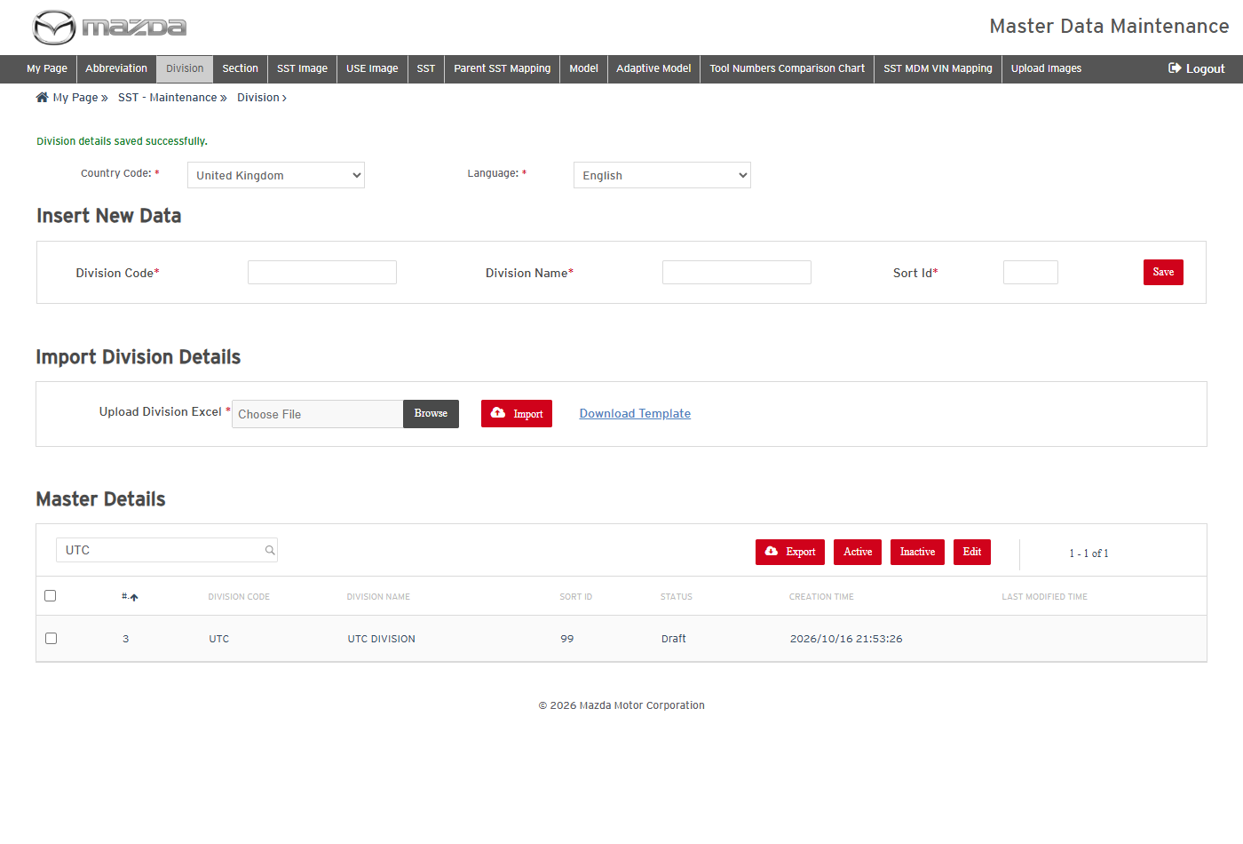
Division saved
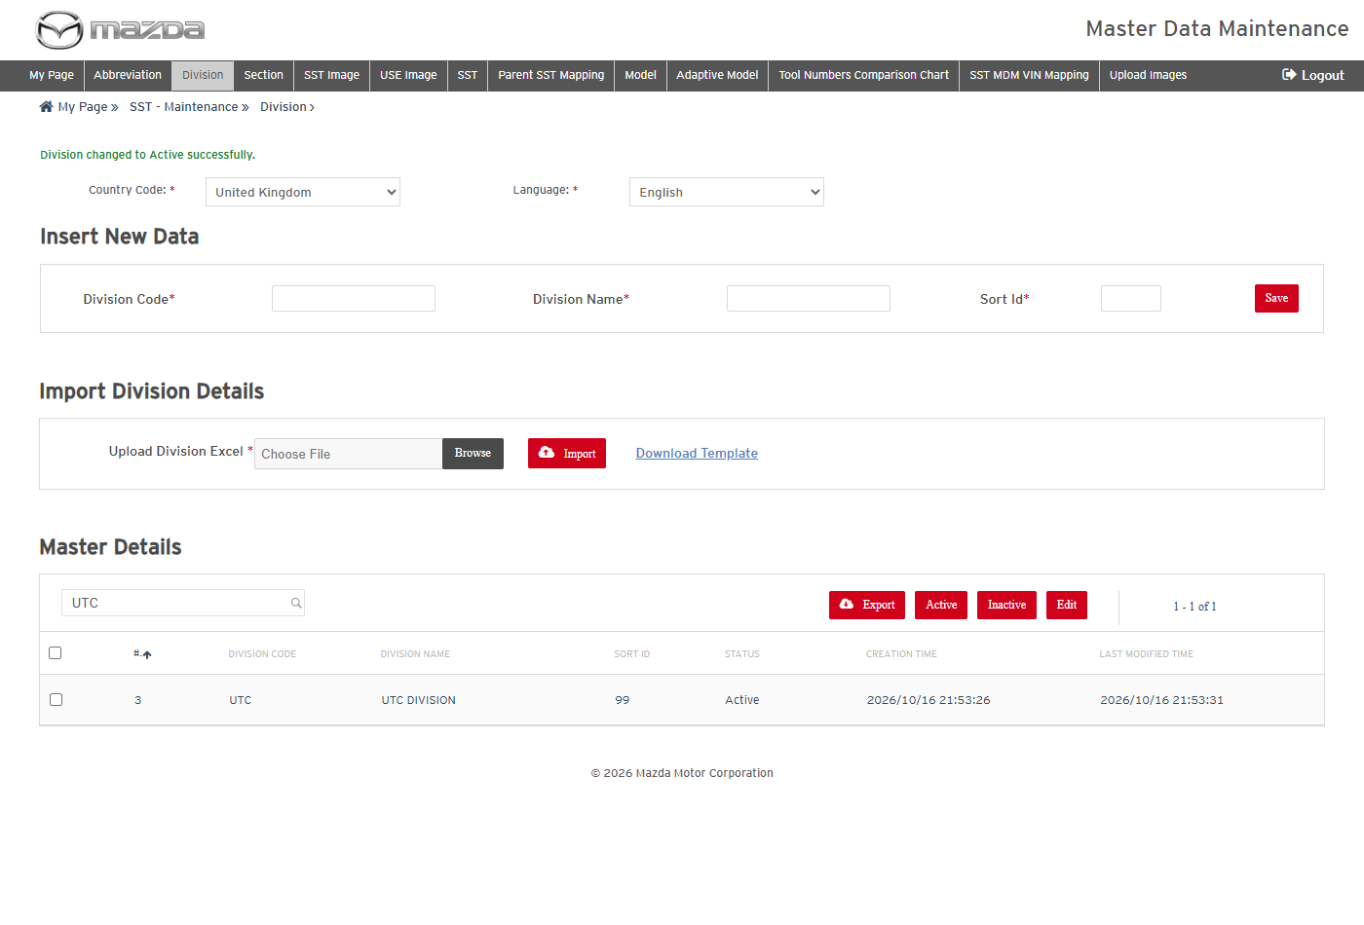
Division active
Status: Pass
Remarks:

- User should be able to export the selected Divisions.
Steps:
1. Select the UTC row and click Export.
2. Open the exported Excel.
Expected Result: The Excel lists the code, name and sort id of the selected division.
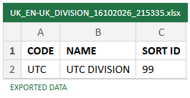
Exported Excel
Status: Pass
Remarks:

2.3 Section
- User should be able to add and activate a Section under a Division.
Steps:
1. Click Section in the top menu and select Country Code United Kingdom and Language English.
2. Select Division UTC DIVISION (UTC), enter Section Code 99, Section Name UTC SECTION, Section Index 99 and Sort Id 99; click Save.
3. Select the UTC SECTION row, click Active and click Yes.
Expected Result:
- The Division list offers the division added on the Division screen.
- "Section details saved successfully." is shown, then "Section changed to Active successfully.".
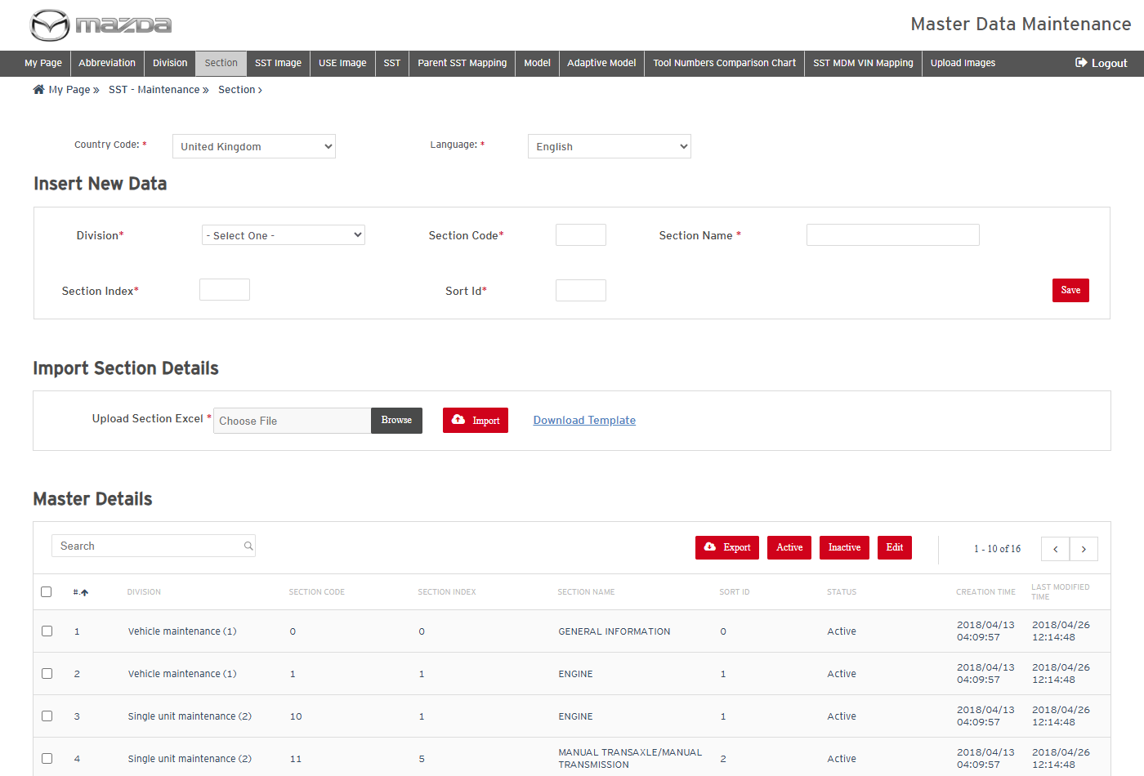
Sections
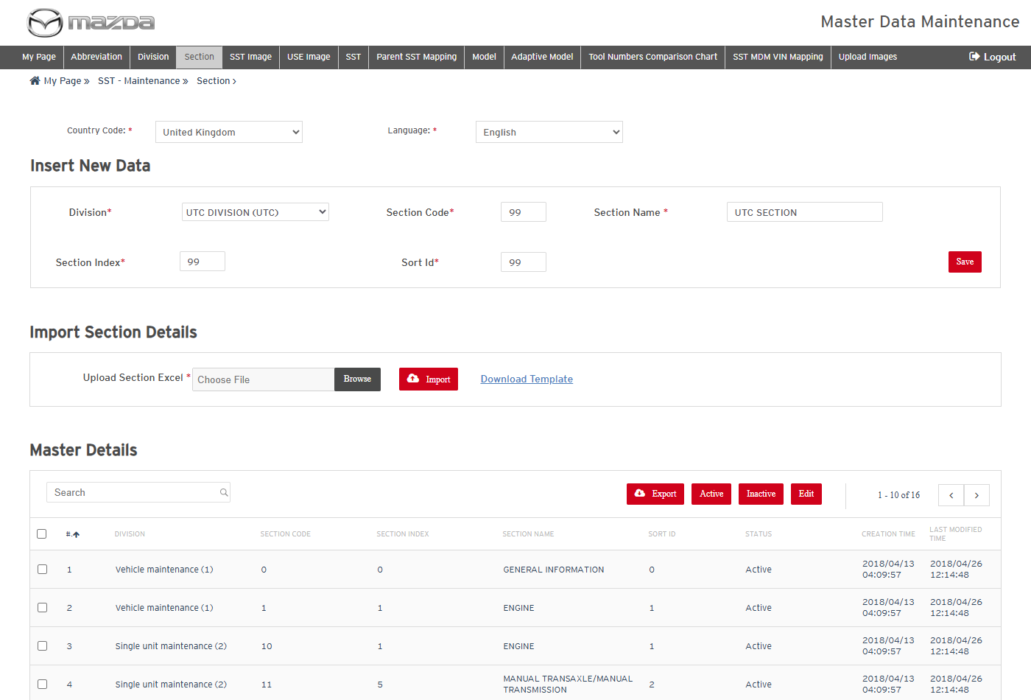
New Section
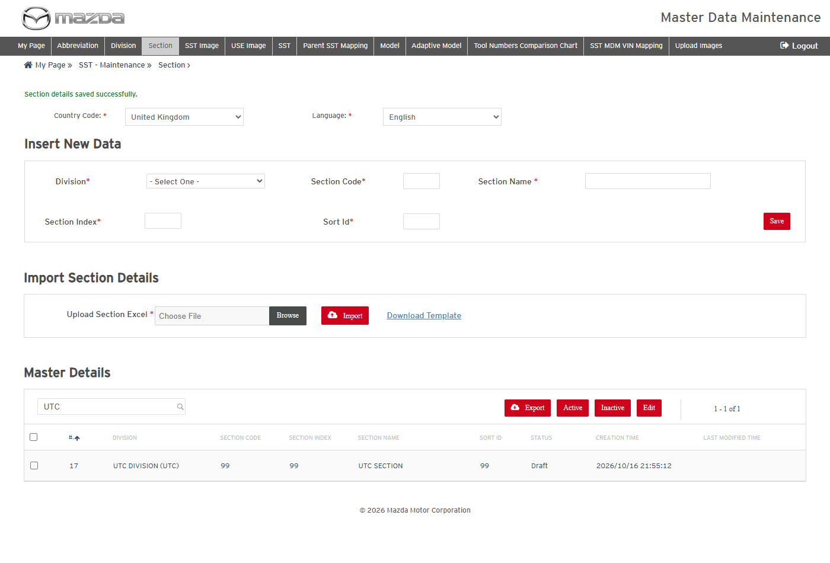
Section saved
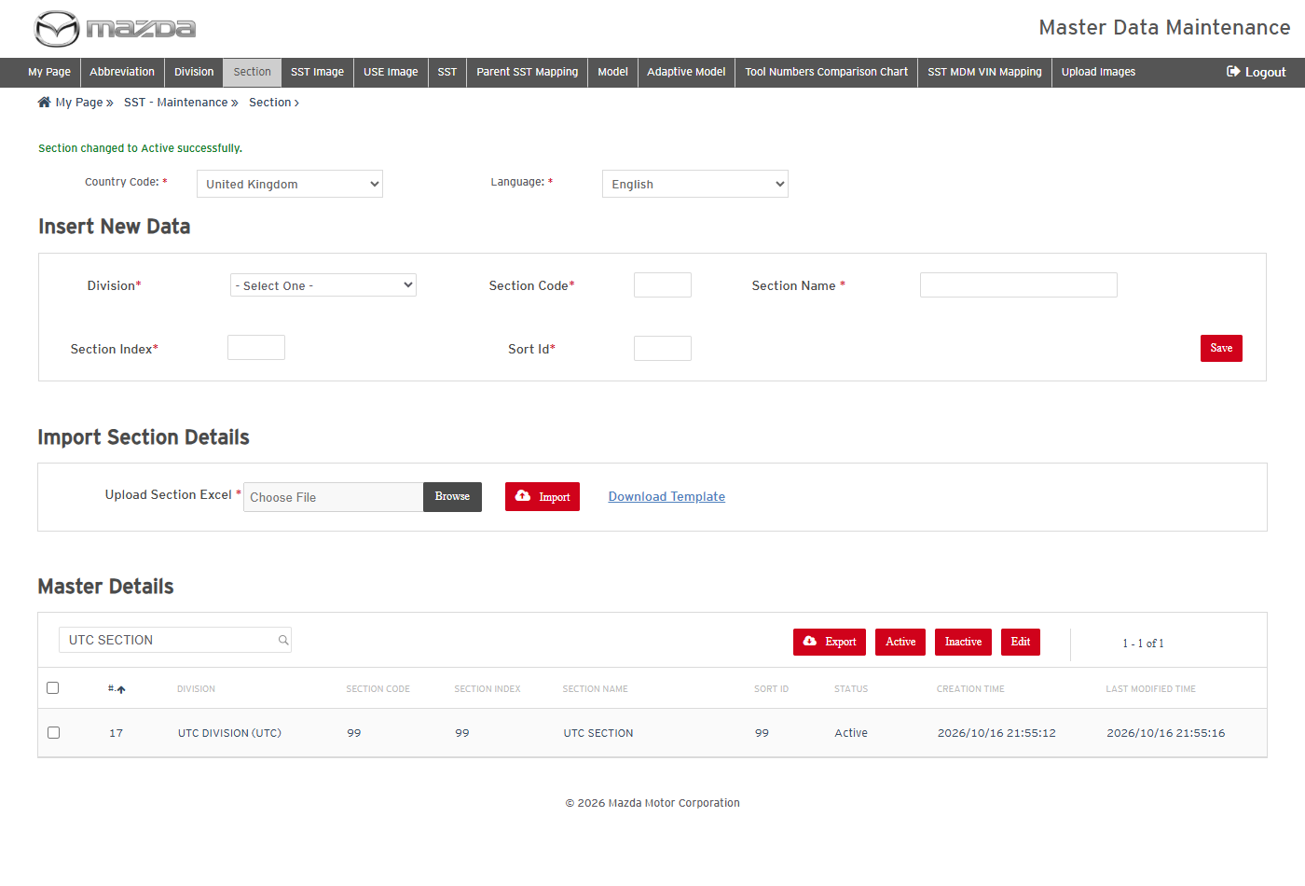
Section active
Status: Pass
Remarks:

- User should be able to add a Section by import (Action A).
Steps:
1. Click Download Template and fill Division Code UTC, Section Code 98, Index 98, Name UTC SECTION 2, Sort Id 98 with Action A.
2. Choose the Excel in Upload Section Excel and click Import.
Expected Result: "1 rows successfully imported." is shown and UTC SECTION 2 is listed under UTC DIVISION.
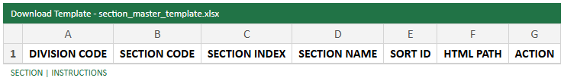
Import template
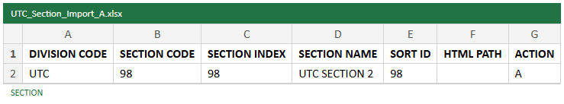
Import file
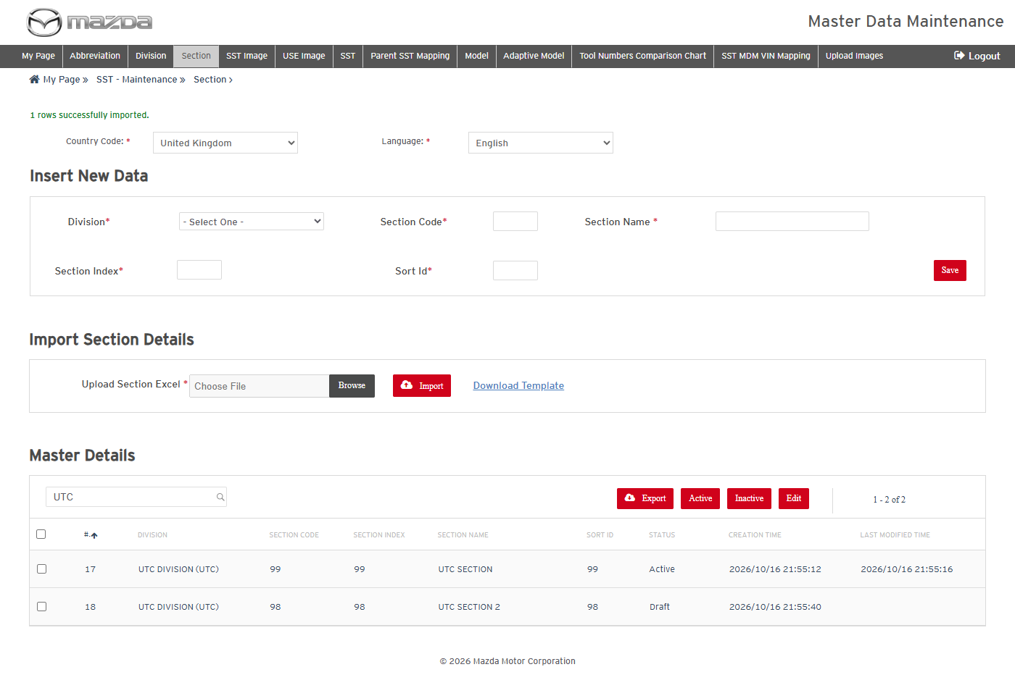
Import result
Status: Pass
Remarks:

2.4 SST
- User should be able to view and search the SSTs.
Steps:
1. Click SST in the top menu and select Country Code United Kingdom and Language English.
2. Enter BALL JOINT in Search.
Expected Result:
- Master Details lists the SSTs of the market (1018 rows) with SST number, name, revision, SST / USE image code and status.
- The search filters the list to the matching SSTs.
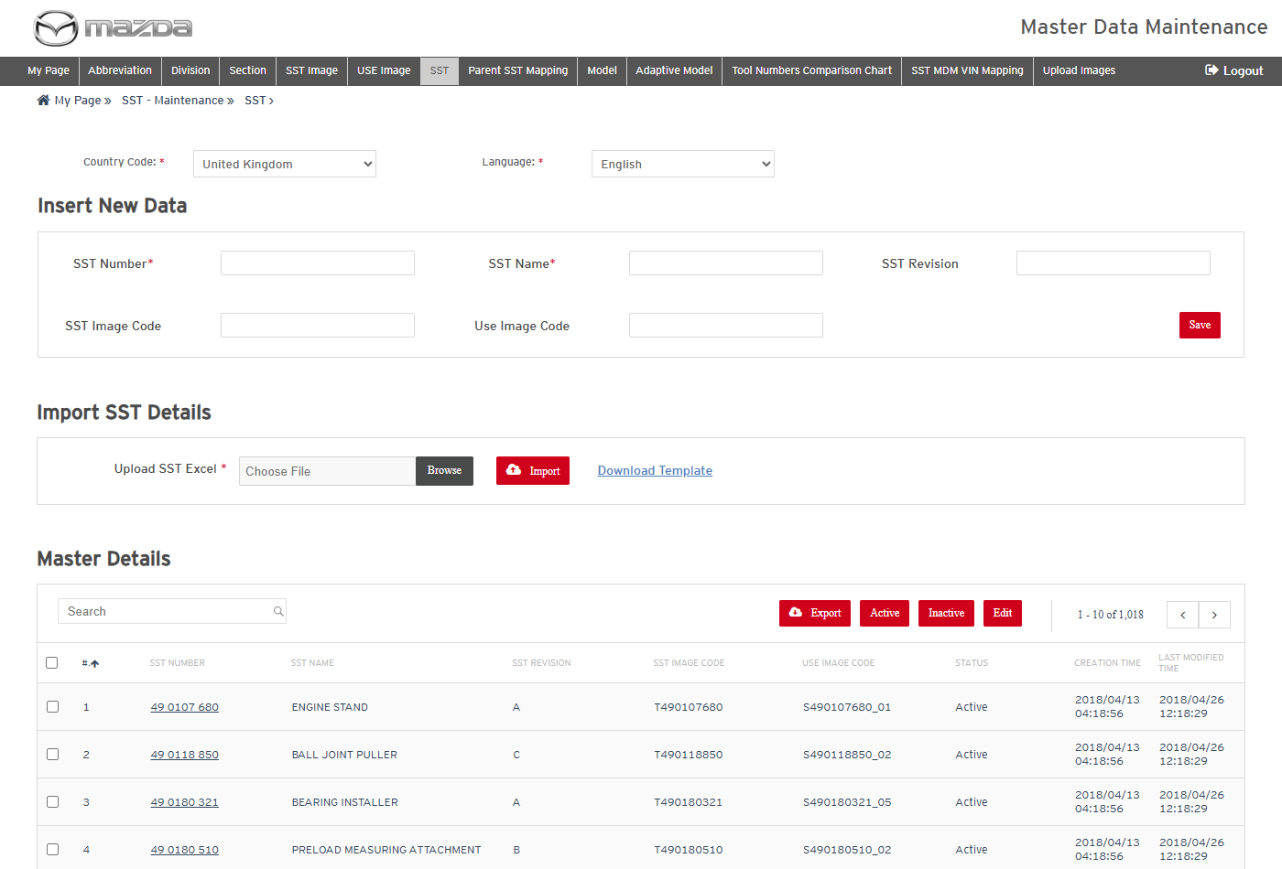
SSTs - United Kingdom / English
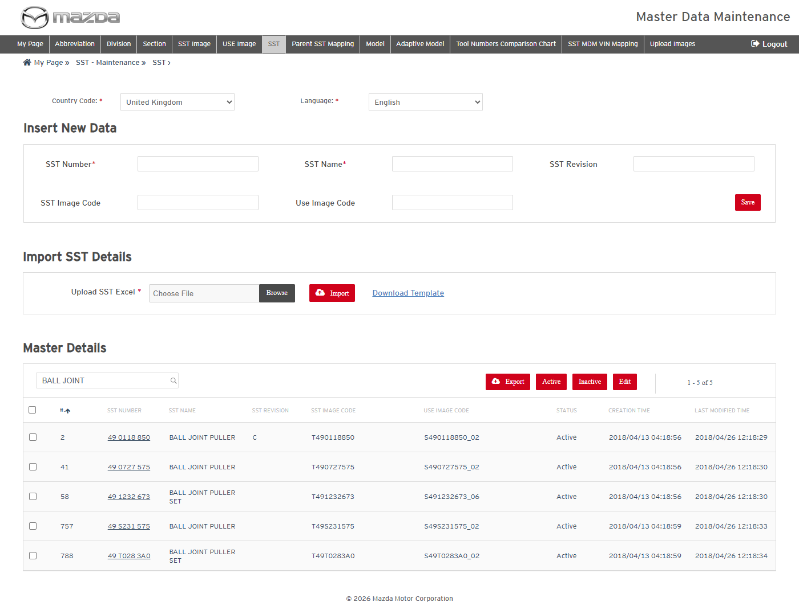
Search BALL JOINT
Status: Pass
Remarks:

- User should be able to add a new SST.
Steps:
1. Enter SST Number 49 UTC0 001, Name UTC TEST TOOL, Revision A, SST Image Code T490107680 and Use Image Code S490107680_01.
2. Click Save.
Expected Result: "SST details saved successfully." is shown and the SST is listed as Draft.
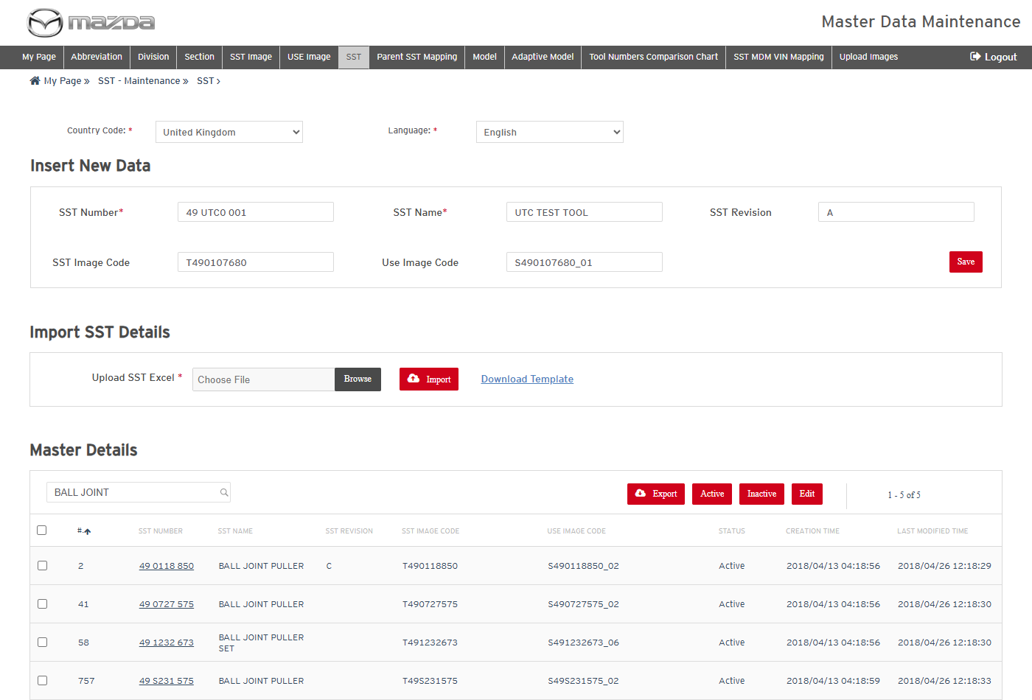
New SST
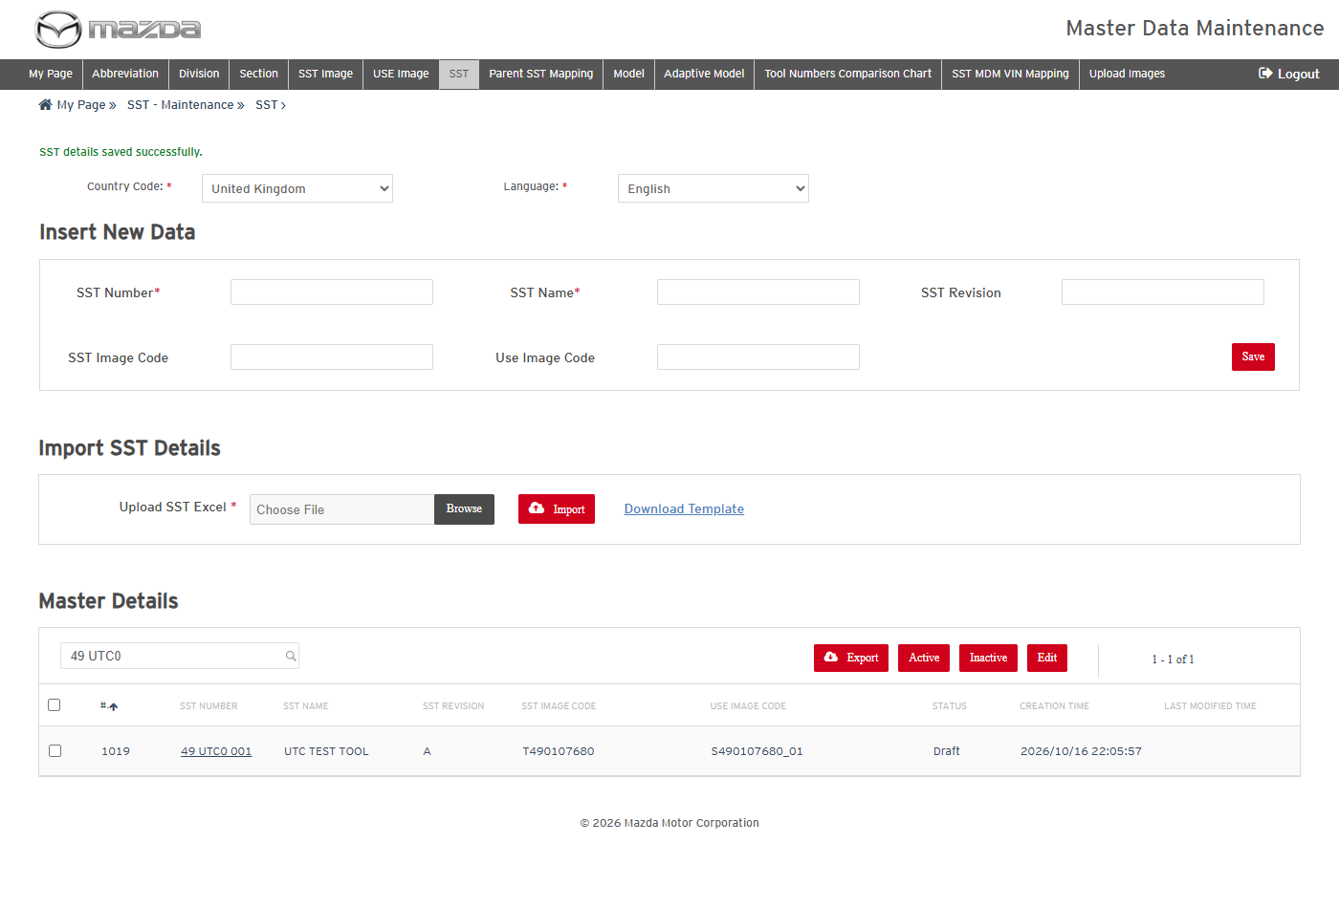
SST saved
Status: Pass
Remarks:

- System should not save an SST with an existing SST Number.
Steps:
1. Enter SST Number 49 UTC0 001 again with a name.
2. Click Save.
Expected Result: "SST Number already exists, it must be unique." is shown and no record is added.
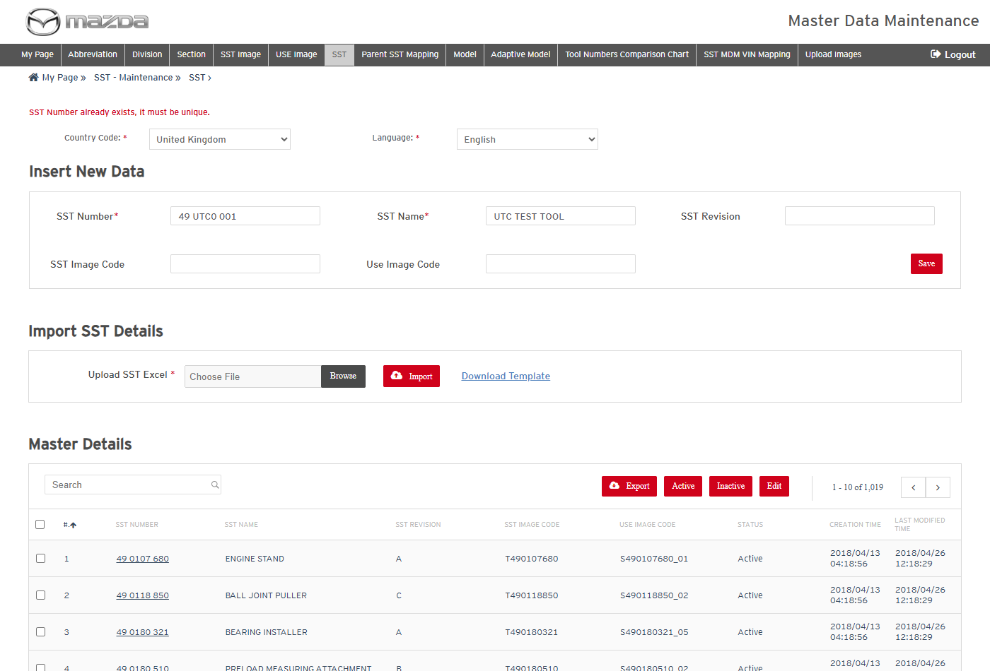
Duplicate SST Number
Status: Pass
Remarks:

- User should be able to edit an SST.
Steps:
1. Select the 49 UTC0 001 row and click Edit.
2. Change the name to UTC TEST TOOL UPDATED.
3. Click Save.
Expected Result: "SST details updated successfully for Row No. (1019)." is shown with the new name.
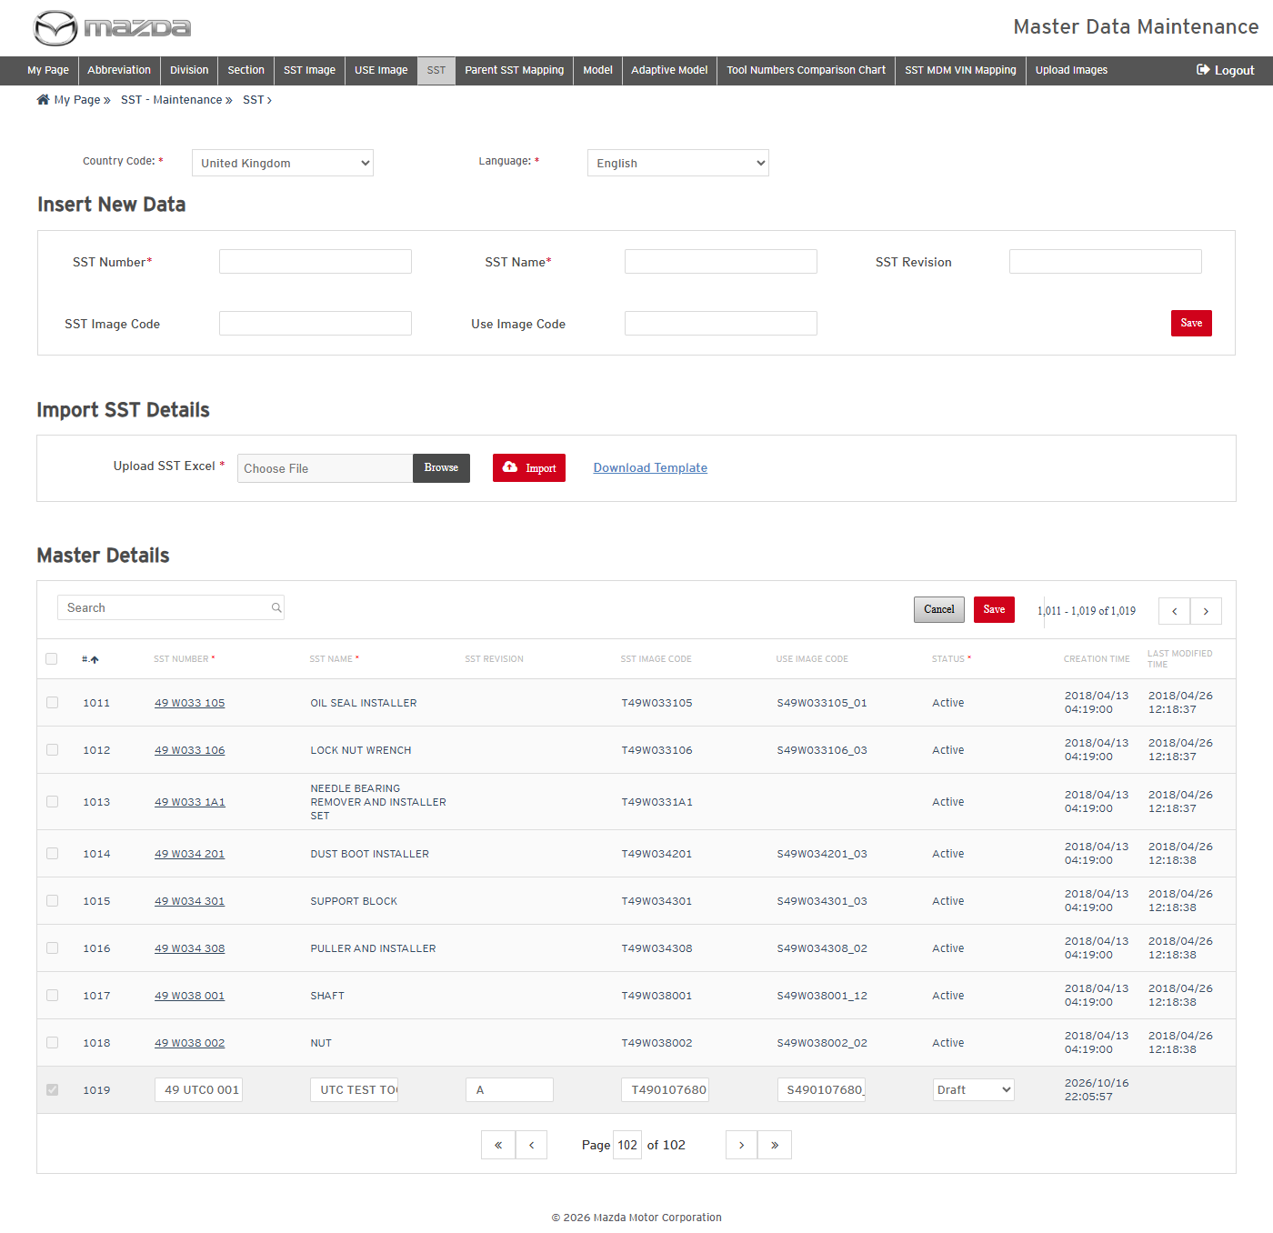
Edit mode
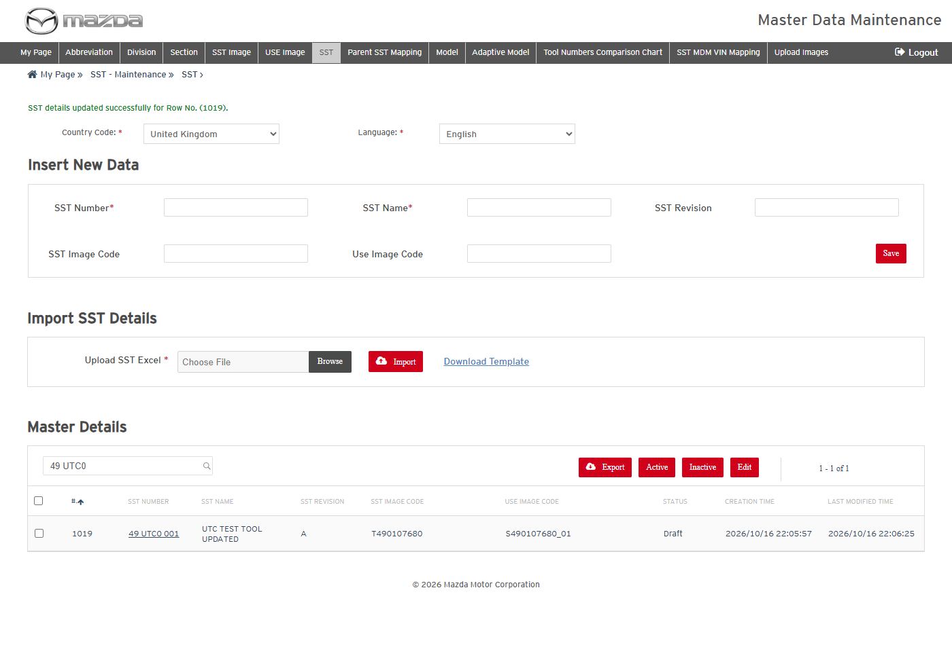
SST updated
Status: Pass
Remarks:

- User should be able to export and activate an SST.
Steps:
1. Select the 49 UTC0 001 row and click Export; open the Excel.
2. Select the row, click Active and click Yes.
Expected Result:
- The Excel lists SST number, name, revision, SST image code and use image code.
- "SST changed to Active successfully." is shown and the status is Active.
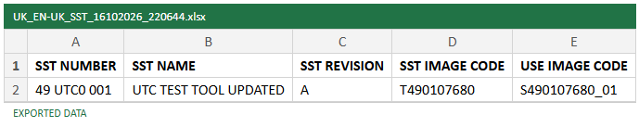
Exported Excel
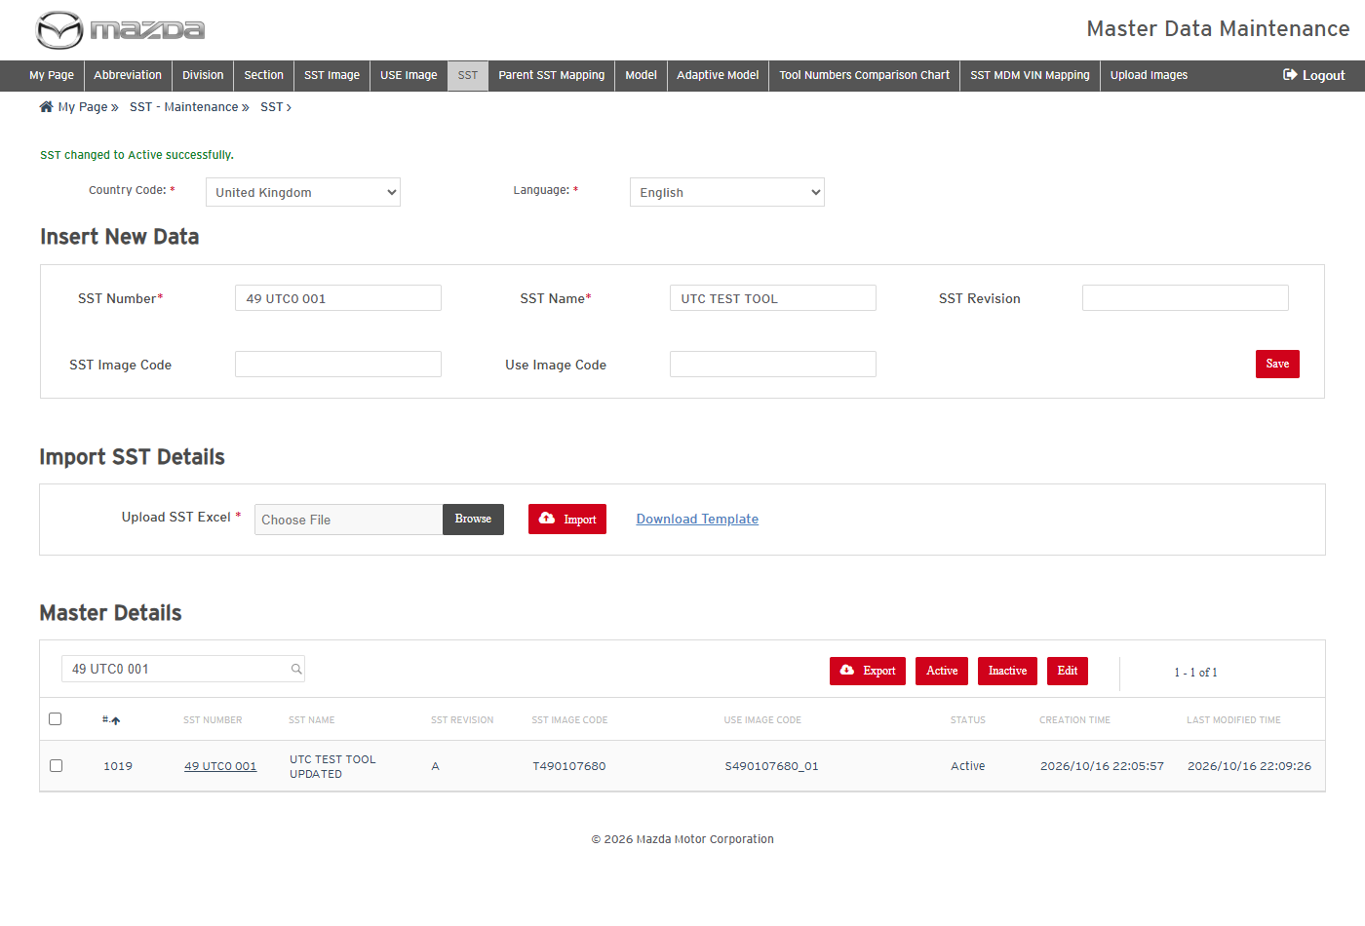
SST active
Status: Pass
Remarks:

- User should be able to add and delete SSTs by import (Action A / D).
Steps:
1. Click Download Template and fill 49 UTC0 002 / UTC TEST TOOL 2 with Action A; import it.
2. Import the same row with Action D.
Expected Result:
- "1 rows successfully imported." is shown and 49 UTC0 002 is listed.
- "1 rows successfully deleted." is shown and 49 UTC0 002 is no longer listed.
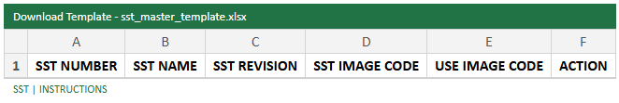
Import template
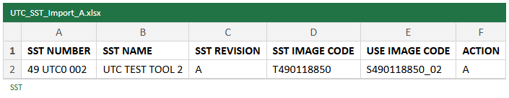
Import file - Action A
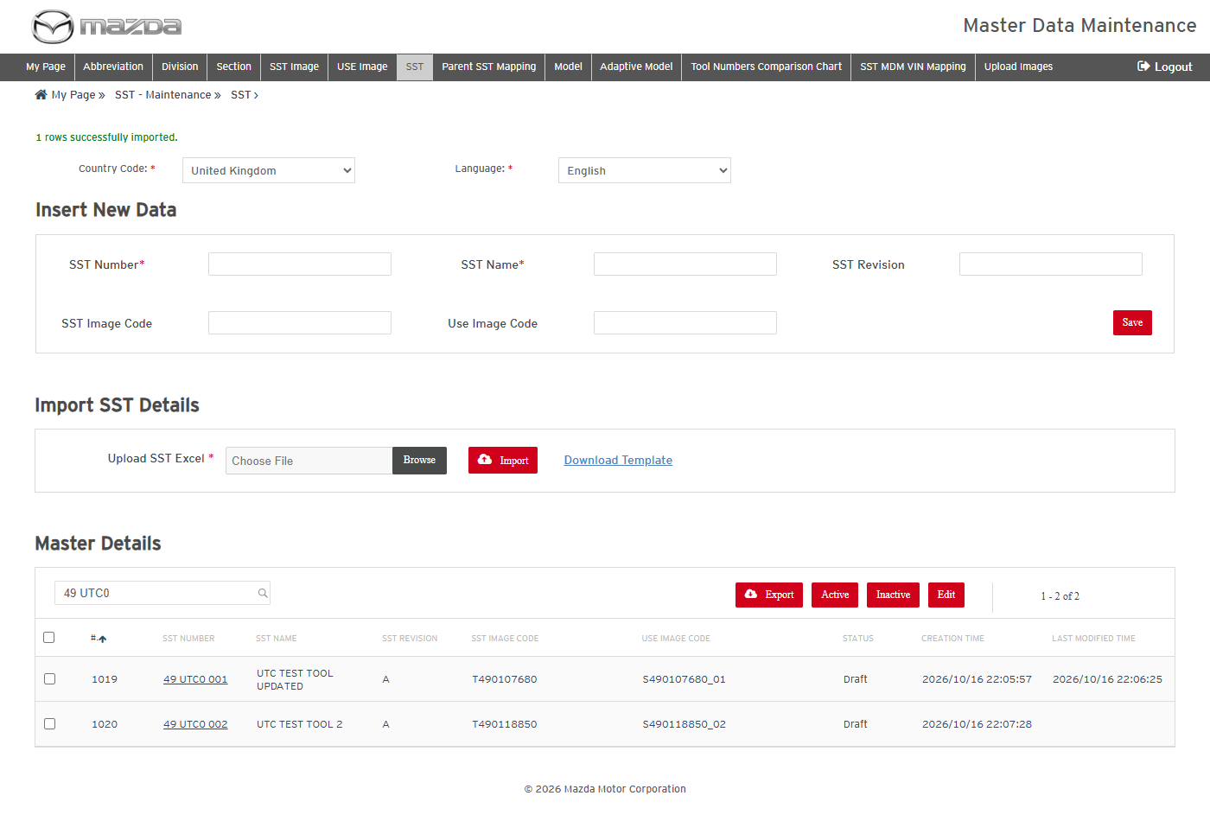
Import result - added
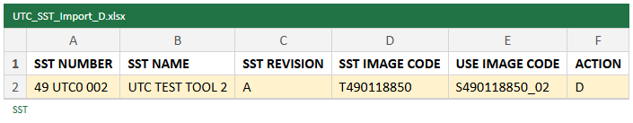
Import file - Action D
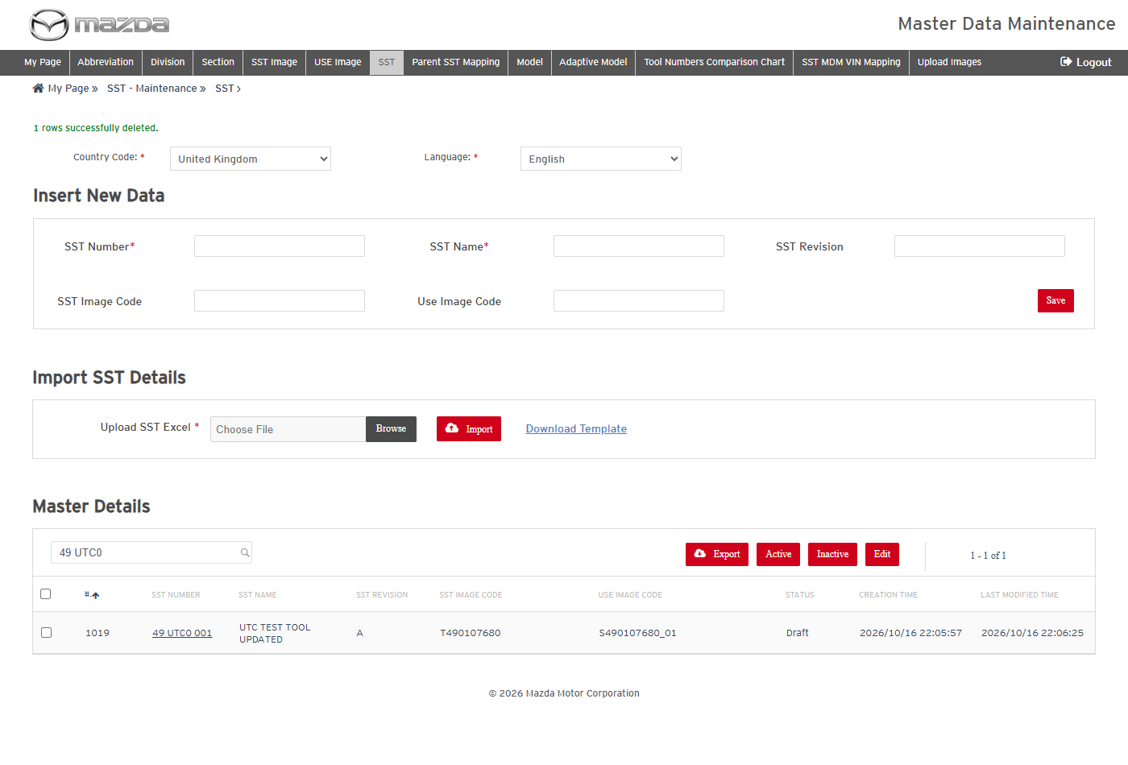
Import result - deleted
Status: Pass
Remarks:

2.5 Model
- User should be able to add and activate a Model (vehicle type) under a Division.
Steps:
1. Click Model in the top menu and select Country Code United Kingdom and Language English.
2. Select Division UTC DIVISION (UTC), enter ESI Model Code UTC, Vehicle Type Code UTCV, Vehicle Type Name UTC VEHICLE and Sort Id 99; click Save.
3. Select the UTCV row, click Active and click Yes.
Expected Result:
- Master Details lists the vehicle types per division.
- "Division Model Mapping details saved successfully." is shown, then "Division Model Mapping changed to Active successfully.".
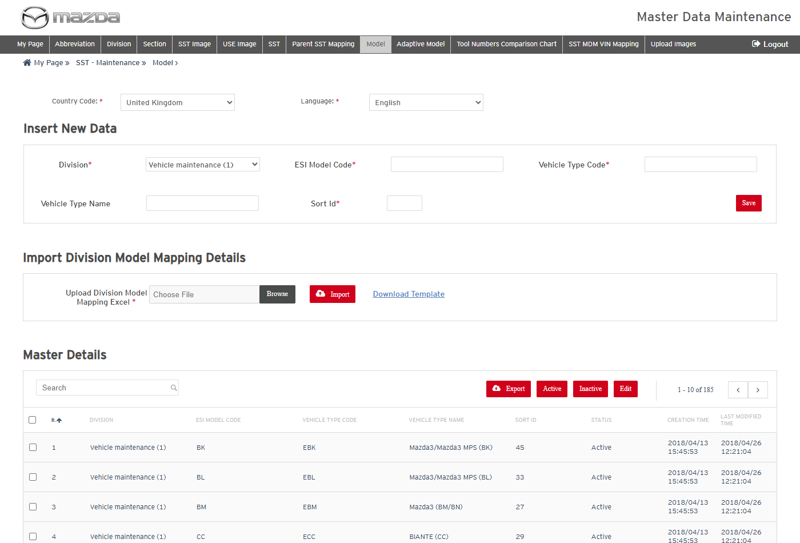
Models
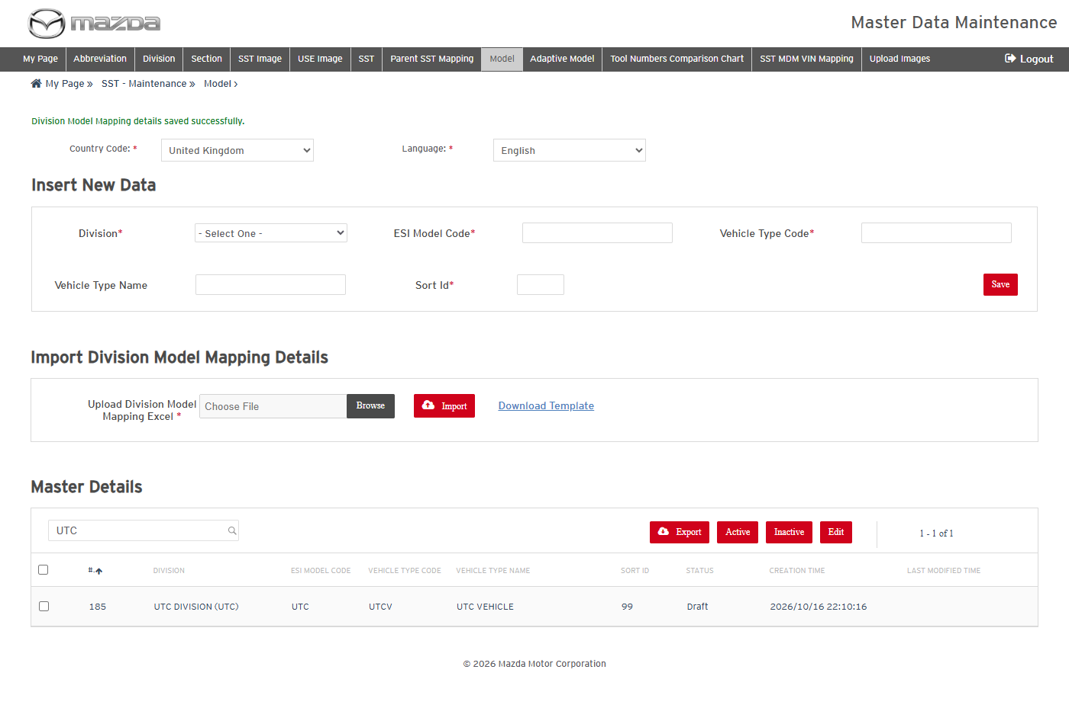
Model saved
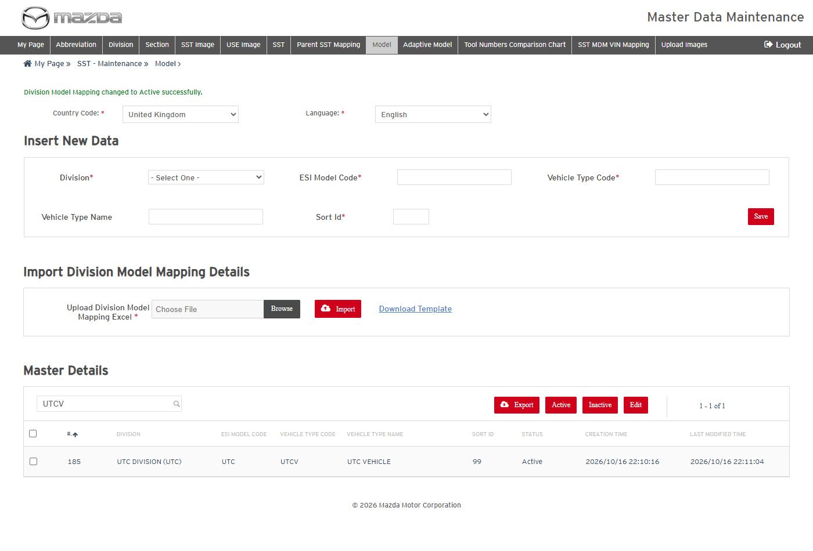
Model active
Status: Pass
Remarks:

SST - Vehicle Type Management
SST - Vehicle Type Management maps the SSTs to a vehicle type and section of a division, using the Division, Section, SST and Model data maintained in SST - Maintenance. Executed with Country Code United Kingdom and Language English.
- User should be able to open Vehicle Types and view the mappings of a Division.
Steps:
1. From My Page > SST Management, click SST - Vehicle Type Management.
2. Select Country Code United Kingdom and Language English and Division Vehicle maintenance (1).
Expected Result: Master Details lists the mappings of the division (vehicle type, section, SST number, remarks, status).
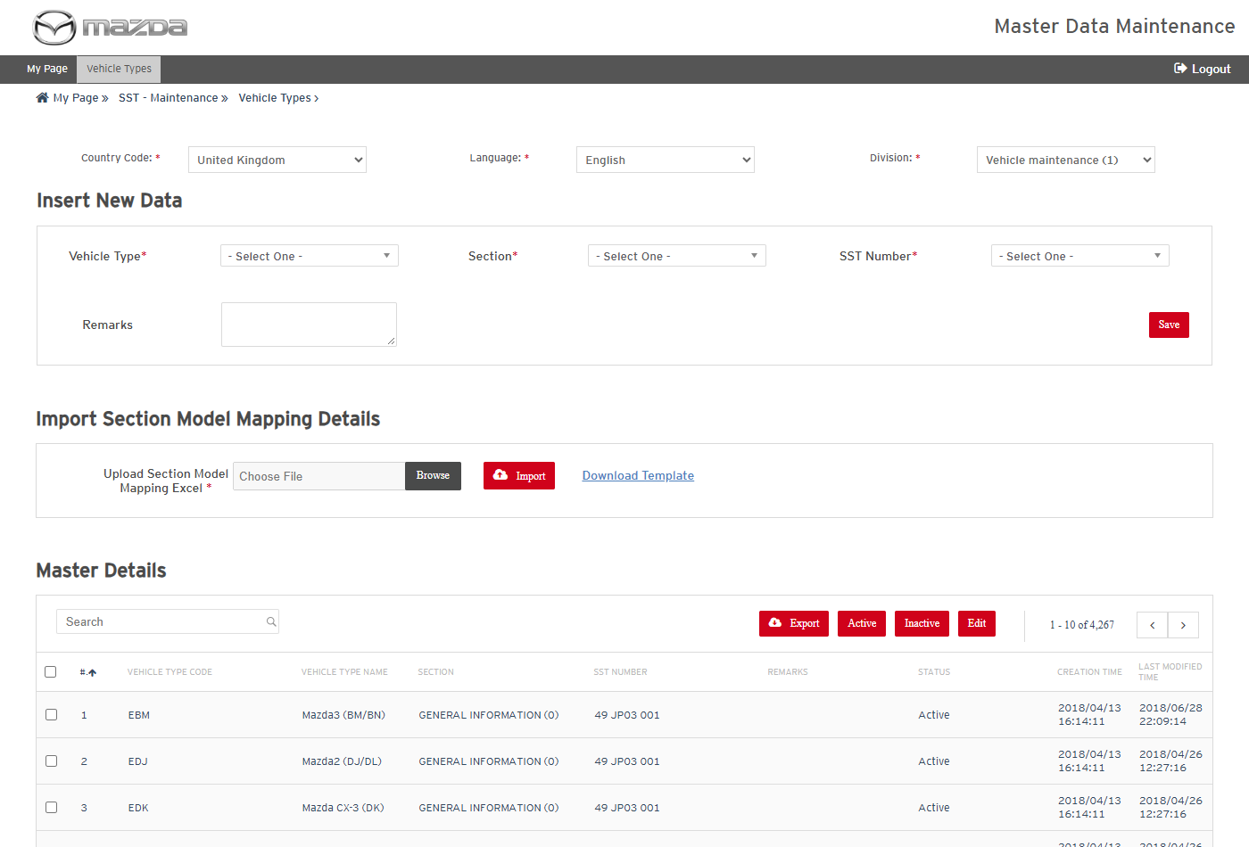
Vehicle Types - Vehicle maintenance
Status: Pass
Remarks:

- System should not save a mapping without the mandatory fields.
Steps:
1. Select Country Code United Kingdom only.
2. Click Save.
Expected Result: "Please fill all the fields marked as mandatory (*)." is shown.
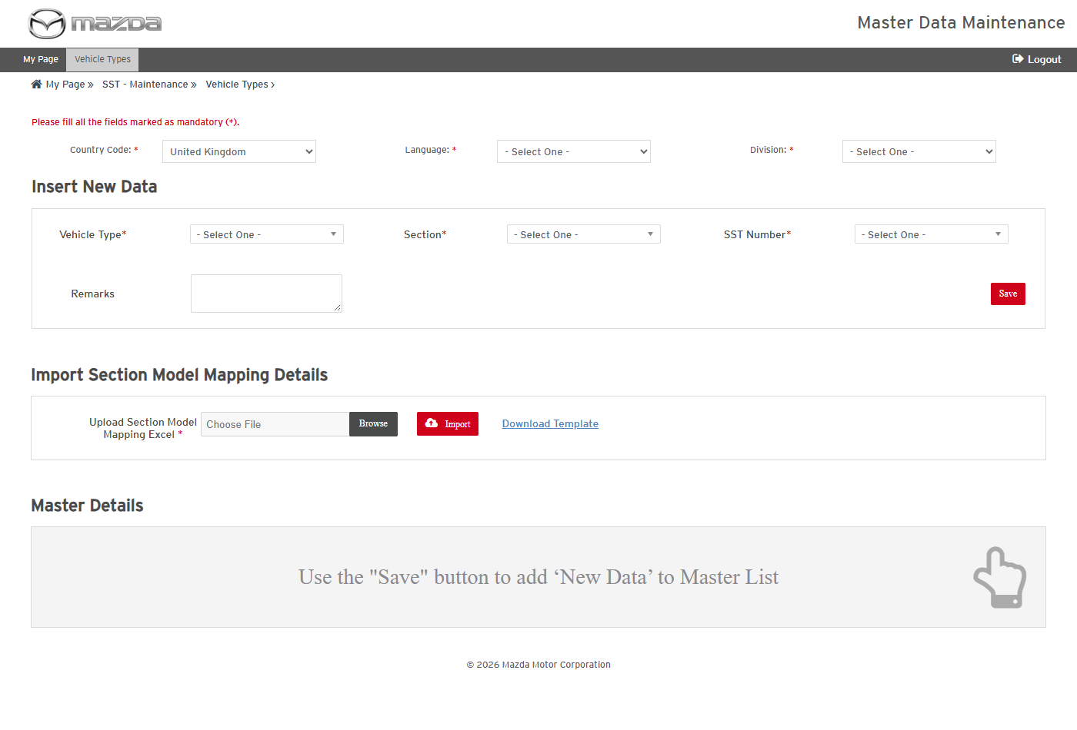
Mandatory field message
Status: Pass
Remarks:

- User should be able to map an SST to a vehicle type and section.
Steps:
1. Select Division UTC DIVISION (UTC).
2. Select Vehicle Type UTC VEHICLE (UTCV), Section UTC SECTION (99), SST Number 49 UTC0 001 and enter Remarks UTC unit test.
3. Click Save.
Expected Result:
- The Vehicle Type, Section and SST Number lists offer the data added in SST - Maintenance.
- "Section Model Mapping details saved successfully." is shown and the mapping is listed.
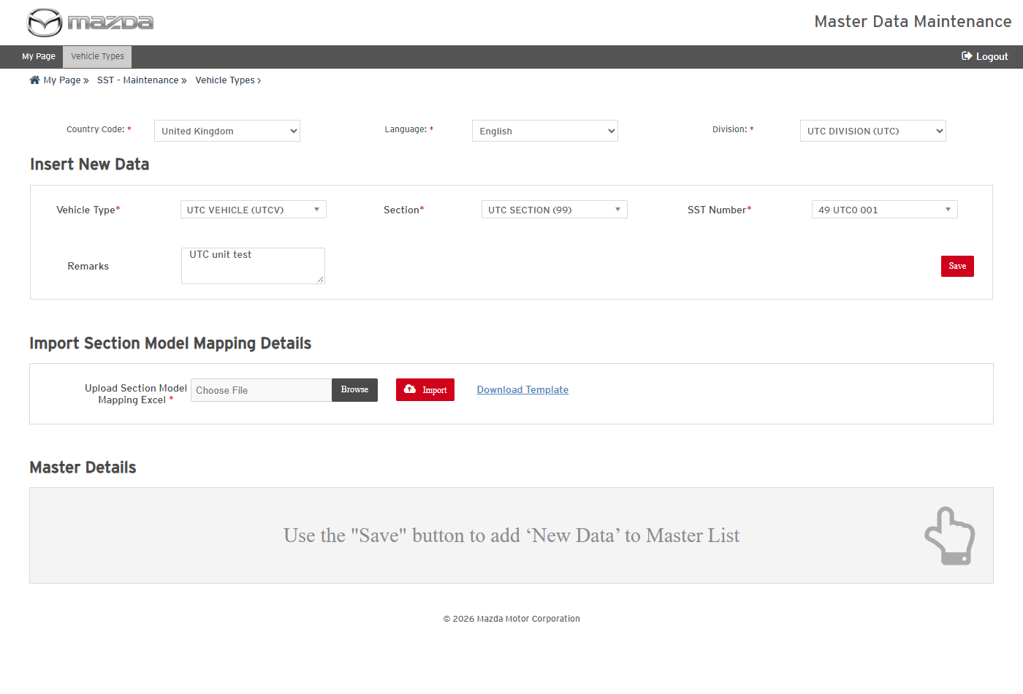
New mapping
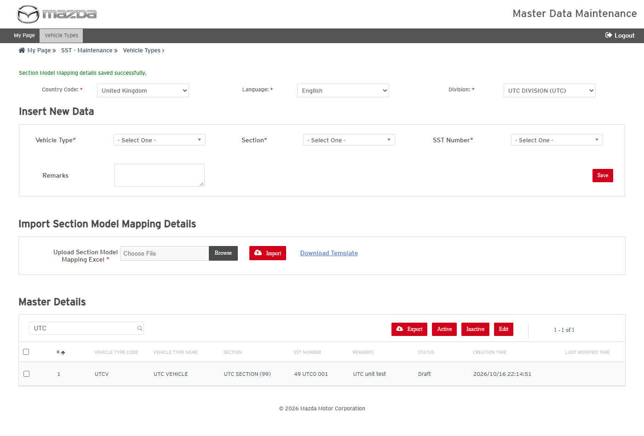
Mapping saved
Status: Pass
Remarks:

- User should be able to export the selected mappings.
Steps:
1. Select the UTCV row and click Export.
2. Open the exported Excel.
Expected Result: The Excel lists the vehicle type, section, SST number and remarks of the selected mapping.
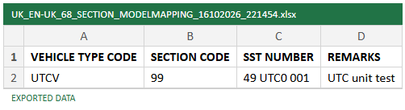
Exported Excel
Status: Pass
Remarks:

- User should be able to add and delete mappings by import (Action A / D).
Steps:
1. Select Division UTC DIVISION (UTC).
2. Click Download Template and fill UTCV / 99 / 49 0118 850 / UTC import with Action A; import it.
3. Import the same row with Action D.
Expected Result:
- "1 rows successfully imported." is shown and the mapping is listed.
- "1 rows successfully deleted." is shown and the mapping is no longer listed.
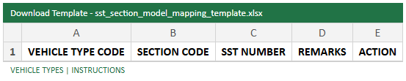
Import template
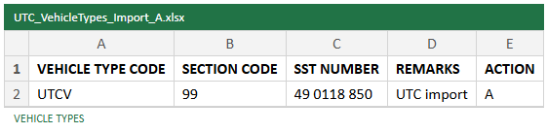
Import file - Action A
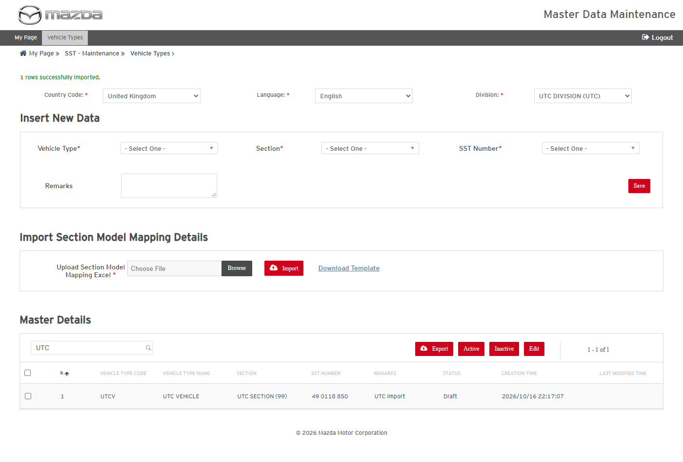
Import result - added
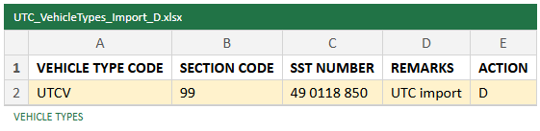
Import file - Action D
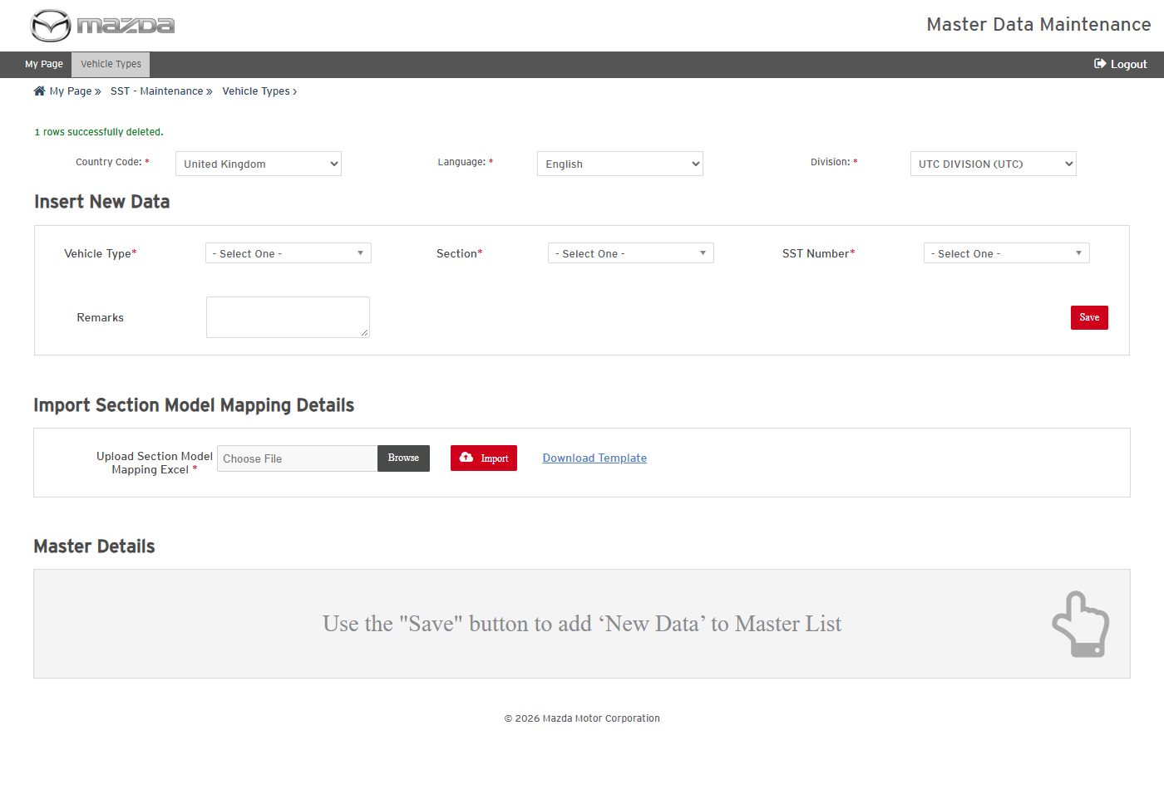
Import result - deleted
Status: Pass
Remarks:

- User should be able to inactivate a mapping.
Steps:
1. Select the UTCV mapping and click Inactive.
2. Click Yes on the confirmation.
Expected Result: "Section Model Mapping changed to Inactive successfully." is shown and the mapping is no longer listed.
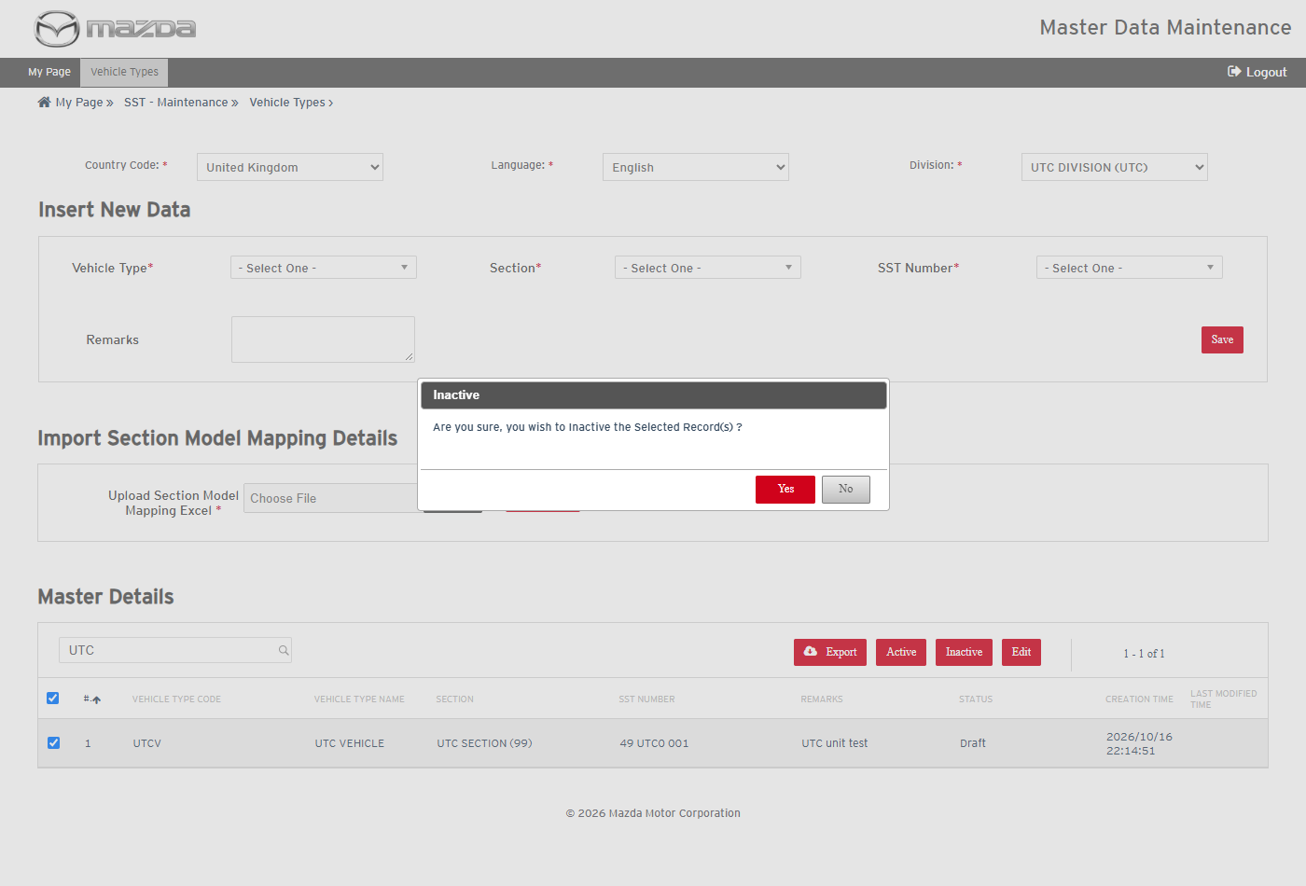
Inactive confirmation
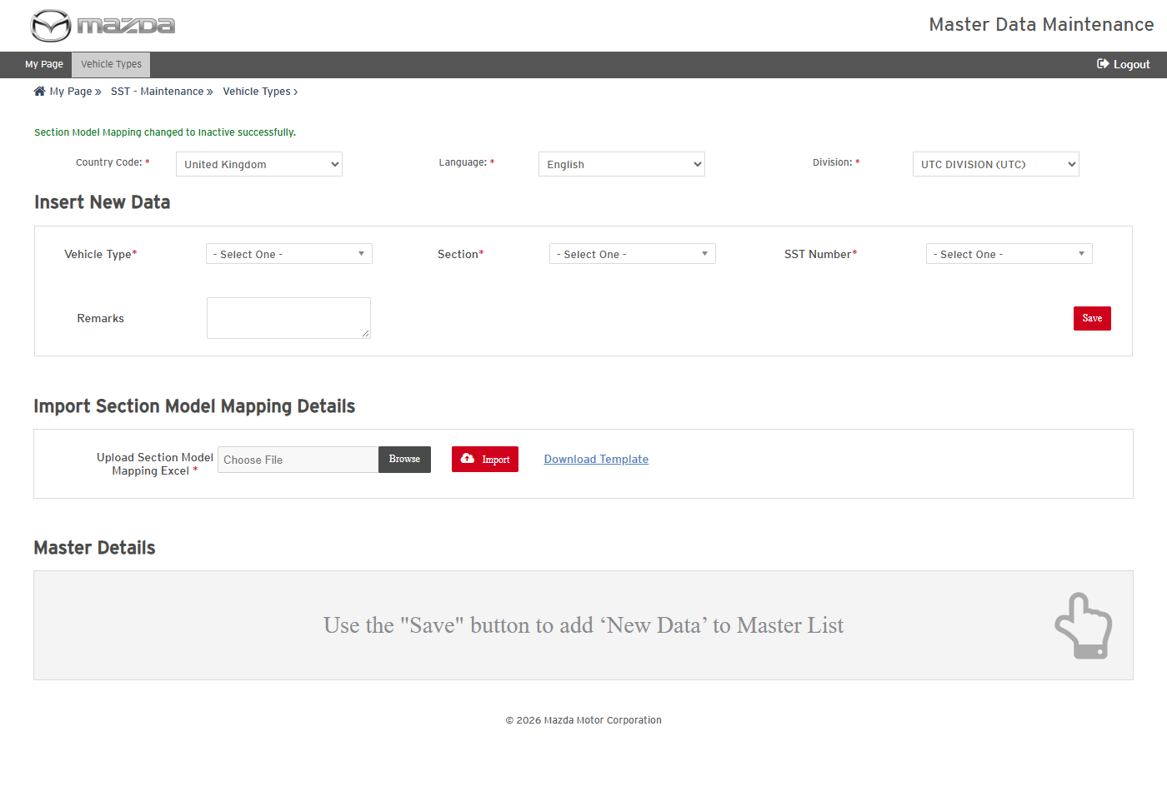
Mapping inactivated
Status: Pass
Remarks:

